**ISDS 577**

**Airline Reviews Sentiment Analysis**

**Final Report**

**Professor:**

Dr. Daniel Soper

**Team 4:**

Anuhya Ramaraju

Jagruti B Jethwani

Krishna Pratheek Seshabhattar

Vamsi Tanneru

Vishnu Sai Tharun Kumar Uppugunduri

**TABLE OF CONTENTS**

Executive Summary……………………………………………………………………………………………………………………1

Introduction…………………………………………………………………………………………………………………………………2

Data Description…………………………………………………………………………………………………………………………3

Data Preparation………………………………………………………………………………………………………………………..5

Transformed Dataset………………………………………………………………………………………………………………..6

Exploratory Data Analysis (Eda)………………………………………………………………………………………………8

Text Pre-Processing…………………………………………………………………………………………………………………24

Implementing Sentiment Methodologies……………………………………………………………………………..26

Correlation Between Vader and TextBlob…………………………………………………………………………….30

Research Questions…………………………………………………………………………………………………………………31

Question 1……………………………………………………………………………………………………………………..33

Question 2……………………………………………………………………………………………………………………..41

Question 3……………………………………………………………………………………………………………………..48

Question 4……………………………………………………………………………………………………………………..56

Question 5……………………………………………………………………………………………………………………..84

Conclusion…………………………………………………………………………………………………………………………………89

References…………………………………………………………………………………………………………………………………92

**EXECUTIVE SUMMARY:**

Our "Airline Reviews Sentiment Analysis" research seeks to conduct a thorough examination of passenger satisfaction in the aviation sector. To learn more about passenger preferences and airline performance, we used a comprehensive dataset derived from Airline Quality evaluations. After being cleaned and processed, this Kaggle dataset—which complies with privacy and legal standards—was improved for analysis.

With an emphasis on both domestic and international flights, we carried out an exploratory data analysis (EDA) to comprehend the distributions of customer ratings, flight frequency, and review counts across various airlines. We used two sentiment analysis methods, VADER and TextBlob, to examine the sentiment in these reviews. These methods enabled us to identify the underlying sentiment patterns in our data.

The project's main conclusions include variations in passenger sentiment over time and the identification of airlines that routinely receive lower sentiment scores, which results in specific recommendations for improvement. The review also included a number of flight departments, including Ground Service, Wi-Fi and connectivity, Food and Beverages, Seat Comfort, Inflight Entertainment, and Cabin Staff Service. It identified areas of underperformance and made specific improvement recommendations.

Welch's T-tests were also carried out, and the results offered strong support for the project's conclusions and suggestions. This research concludes by highlighting the important role that data-driven initiatives play in improving customer experience and directing business choices in the airline industry. It also shows how meticulous analysis may result in increases in service quality and passenger happiness.

**INTRODUCTION:**

The airline sector is essential to enabling international travel in today's connected world. Airlines are trusted by customers to put safety, comfort, and a positive flight experience first. It can be difficult, though, to comprehend the subtleties of various airline options and to assess how well they function in the context of the wide range of passenger opinions.

Our initiative aims to illustrate the important role that data plays in the airline business. We want to detangle the complications surrounding airline selections by obtaining important insights and examining diverse viewpoints and trends that influence traveler preferences. The information we gather forms the basis for recommendations for enhancements and the identification of key issues unique to various departments related to the flights. Ultimately, our project emphasizes the positive impact that data can have in bringing about improvements within the airline industry.

**DATA DESCRIPTION:**

[Airline Quality](https://www.airlinequality.com/) is the source of airline reviews, where travelers can record their experiences and reviews with different airlines. We are using data from a structured dataset available on [Kaggle](https://www.kaggle.com/datasets/khushipitroda/airline-reviews) that has been web-scraped from Airline Quality using beautifulsoup.

Adherence to data privacy and website terms was observed. There are no legal or privacy concerns with the dataset we are using. The data was available in. CSV format.

Our dataset contains 23,172 rows, including labels (i.e., 23,171 observations).

It contains the following variables:

1. Airline Name: Names of the various Airlines in the dataset.
2. Overall_Rating: Rating given by a customer for that flight (0-9).
3. Review_Title: Title of the review given by the customer for that flight.
4. Review Date: Date of the review given by the customer.
5. Verified: Whether the review is verified or not.
6. Review: Text of the review
7. Aircraft: Aircraft number (E.g., CRJ-900, A319 etc.)
8. Type Of Traveler: Description about the type of the traveler (E.g., Solo or leisure or family etc.)
9. Seat Type: The type of seat the traveler has travelled in (E.g., Economy, or Business etc.)
10. Route: Route of the flight with layovers.
11. Date Flown: Departure date and time of the flight.
12. Seat Comfort: Rating given by the customers for Seat Comfort (0-5).
13. Cabin Staff Service: Rating given by the customers for Cabin Staff Service (0-5).
14. Food & Beverages: Rating given by the customers for Food & Beverages (0-5).
15. Ground Service: Rating given by the customers for Ground Service (0-5).
16. Inflight Entertainment: Rating given by the customers for Inflight Entertainment (0-5).
17. Wi-Fi & Connectivity: Rating given by the customers for wife & Connectivity (0-5).
18. Value For Money: Rating given by the customers for Value for money (0-5).
19. Recommended: If the flight is recommended or not, given by customers (yes or no)

**DATA PREPARATION:**

We started with the data cleansing process. We substituted the missing entries for missing text data with 'N/A.' In the case of missing numeric values, we replaced them with the mean value, rounded to the nearest whole number.

We considered performing minor data transformations to bring out effective insights that can help airlines improve their customer satisfaction. They are as follows:

We dropped columns irrelevant to our analysis: Review Date, Verified, Aircraft, Value For Money, and Recommended.

Filtered down the dataset to airlines only containing 100 reviews each.

**Transformed the following columns:**

1. Split the “Date Flown” column into “Date Flown” and “time” and dropped the “time” column.

2. Mapped all the departments (Seat Comfort, Cabin Staff Service, Food & Beverages, Ground Service, Inflight Entertainment, Wi-Fi & Connectivity) to 5 levels of satisfaction (Very Dissatisfied, Dissatisfied, Neutral, Satisfied, Very Satisfied) based on the rating given by the customer (0-5)

3. Split the “Route” column into 3 columns “departure”, “destination” and “layover” and dropped the “layover” column.

4. Created “in_usa” column using geolocation API from google. This checks if the city in the “departure” column is in the USA or not and gives TRUE if it is in the USA.

We further filtered the dataset, choosing only the airlines whose value is TRUE in the “in_usa” column.

5. Created a “destination_country” column using the same API. This has the country names of the cities in the “destination” column.

6. Created “destination_in_USA” column. Gives TRUE if the “destination_country” is the United States.

7. Created “flight_type” column. Gives the value “International” if “in_usa” is TRUE and “destination_in_USA” is FALSE. Gives the value Domestic, if “in_usa” is TRUE and “destination_in_USA” is also TRUE.

**TRANSFORMED DATASET:**

After performing the necessary data cleaning and transformations, our final dataset has 2589 rows including the Labels (i.e., 2588 observations) with data across 19 variables.

the final dataset “airlines_type” had the following attributes:

1. Airline Name: Names of the various Airlines in the dataset.
2. Overall_Rating: Rating given by a customer for that flight (0-9).
3. Review_Title: Title of the review given by the customer for that flight.
4. Review: Text of the review.
5. Type Of Traveler: Description about the type of the traveler (E.g., Solo or leisure or family etc.)
6. Seat Type: The type of seat the traveler has travelled in (E.g., Economy, or Business etc.)
7. Date Flown: Departure date of the flight.
8. Seat Comfort: Contains 5 levels of satisfaction based on the ratings given.
9. Cabin Staff Service: Contains 5 levels of satisfaction based on the ratings given.
10. Food & Beverages: Contains 5 levels of satisfaction based on the ratings given.
11. Ground Service: Contains 5 levels of satisfaction based on the ratings given.
12. Inflight Entertainment: Contains 5 levels of satisfaction based on the ratings given.
13. Wi-fi & Connectivity: Contains 5 levels of satisfaction based on the ratings given.
14. departure: Has the departure cities.
15. destination: Has the destination cities
16. in_usa: Has true or false values. Referencing the departure column. TRUE if departure city is in USA.
17. destination_country: Refers to the cities in the destination column, contains the country of that city.
18. destination_in_USA: Contains TRUE or FALSE values. Refers to the destination_country and gives TRUE if the country is United States.
19. flight_type: Has values International and Domestic.

**EXPLORATORY DATA ANALYSIS (EDA):**

**Distribution of ratings:**

Figure 1

This histogram displays the distribution of overall ratings given by passengers for domestic flights. The x-axis represents the rating values, while the y-axis represents the frequency or count of ratings. The plot shows the distribution's shape and the ratings' concentration around certain values. We can see that the concentration of the rating is more towards the lower end of the distribution. 858 customers have given an overall rating of 1 for the domestic flights, followed by ratings 2 and 3.

Figure 2

This histogram displays the distribution of overall ratings given by passengers for international flights. The x-axis represents the rating values, while the y-axis represents the frequency or count of ratings. The plot shows the distribution's shape and the ratings' concentration around certain values. We can see that the concentration of the rating is more towards the lower end of the distribution for international flights too. 848 customers have given an overall rating of 1 for the international flights, followed by ratings 2 and 3.

**Frequency Distribution of Date Flown:**

Figure 3

This line plot shows the trend of domestic flights over the years in our data. The x-axis represents the years from the “Date Flown” column, and the y-axis represents the count of flights in those specific years. It provides insights into patterns and variations in the number of flights over time. From this, we can see that the frequency of flights has dropped from 2015 to 2016, followed by a rise towards 2017 and a drop towards 2020. From 2021, we can see a constant rise in the number of flights till 2023. The reason for the rise in the count of flights from 2021 may be due to the increase in the collection of review data from the customers, as it would be helpful in the collection of post-COVID-19 flight reviews.

*Figure 4*

This line plot shows the trend of international flights over the years in our data. From this, we can see that the frequency of flights has increased from 2014 to 2019, followed by a drop towards 2020, which continued till 2021. The restriction of international travel justifies this drop during and after the pandemic. From 2021, we can see a constant rise in the number of flights till 2023. The rise in the count of flights from 2021 may be due to the increase in the collection of review data from the customers, as it would be helpful in the collection of post-COVID-19 flight reviews and the restart of international travel.

**Distribution of Airlines:**

Figure 5

This bar plot visualizes the review count distribution of domestic airlines in the dataset. Each bar represents an airline, and the height of each bar corresponds to the count of reviews for that airline. The x-axis represents the airline names, while the y-axis represents the reviews count. While we were transforming our initial dataset, we first chose airlines with a count of 100 reviews for each airline and then chose the airlines that were only departing from the USA so that we could filter between International and Domestic flights originating only from the USA. Hence, we can see an instability in the review count. A graph with purple lines

Figure 6

The distribution shows the review count for flights in the international category. The reason for inconsistency in the review count in this category is also due to the choice of airlines, with a count of 100 reviews for each airline and then the selection of airlines that were only departing from the USA so that we could filter between International and Domestic flights originating only from the USA.

**Distribution of Type of Travelers:**

Figure 7

This count plot shows the distribution of different types of travelers in the dataset for domestic flights. The x-axis represents the traveler type (e.g., Solo, Business, Couple, etc.), while the y-axis represents the count of reviews from each traveler type. From this, it can be seen that the solo leisure traveler has a high count with 405 travelers, followed by family leisure travelers and couple leisure travelers with business at the least.

Figure 8

This count plot shows the distribution of different types of travelers in the dataset for international flights. The x-axis represents the traveler type (e.g., Solo, Business, Couple, etc.), while the y-axis represents the count of reviews from each traveler type. From this, it can be seen that the international and domestic categories follow a similar trend, with solo leisure travelers having a high count of 451 travelers, followed by family leisure travelers, and a couple-leisure travelers with business at the least.

**Count of Seat Type vs. Flight Type:**

Figure 9

This bar chart shows the number of reviews based on seat types on Domestic flights. The Economy Class bar is significantly taller than the others, indicating a much higher count. The other bars are much shorter, suggesting a lower frequency of those seat types.

Figure 10

This bar chart shows the number of reviews based on seat types on international flights. Economy Class has the highest count at 1093, followed by Business Class, Premium Economy, and First Class.

For easier understanding of the visualizations, we mapped the numerical ratings given by the customers to categorical satisfaction levels.

**Distribution of Seat Comfort vs. Flight Type:**

This stacked bar chart shows the distribution of ratings given by customers for the seat comfort department for both international and domestic flight types. The color legend is provided for reference.

Figure 11

The x-axis represents the seat comfort satisfaction levels, and the y-axis represents the count of customers who have given that particular rating.

From this chart, we can see that most of the customers in both international and domestic categories have given a rating of “Very Dissatisfied” for the flights. 568 customers were very dissatisfied with seat comfort in the domestic category, and 510 customers were very dissatisfied with seat comfort in the international category.

**Distribution of Cabin Staff Service vs. Flight Type:**

The stacked bar chart displays passenger satisfaction with cabin staff service for both domestic and international. The color legend is provided for reference.

Figure 12

The x-axis represents the cabin staff services satisfaction levels, and the y-axis represents the count of customers who have given that particular rating.

From this chart, we can see that most of the international and domestic customers have rated “Very Dissatisfied” for the flights. 518 customers were very dissatisfied with cabin staff service in the domestic category, and 452 customers were very dissatisfied with cabin staff service in the international category.

**Distribution of Food and Beverages vs. Flight Type:**

Figure 13

The x-axis represents the Food and Beverages department’s satisfaction levels, and the y-axis represents the count of customers who have given that rating.

From this chart, we can see that most of the international and domestic customers have rated “Neutral” for the flights. 559 customers were neutrally satisfied with food and beverages in the domestic category, and 499 customers were neutrally satisfied with food and beverages in the international category.

**Distribution of Ground Services vs. Flight Type:**

The stacked bar chart illustrates customer feedback on ground service quality for domestic and international flights. The color-coded legend differentiates the satisfaction levels for each flight type.

Figure 14

The x-axis represents the Ground services satisfaction levels, and the y-axis represents the count of customers who have given that rating.

From this chart, we can see that most of the international and domestic customers have rated “Very Dissatisfied” for the flights. 836 customers were very dissatisfied with seat comfort in the domestic category, and 714 customers were very dissatisfied with ground service in the international category.

**Distribution of Inflight Entertainment vs. Flight Type:**

Figure 15

The x-axis represents the Inflight Entertainment department’s satisfaction levels, and the y-axis represents the count of customers who have given that rating.

This chart shows that most of the international and domestic customers have rated “Dissatisfied” for this department. 675 customers were dissatisfied with inflight entertainment in the domestic category, and 580 customers were dissatisfied with inflight entertainment in the international category.

**Distribution of Wi-Fi & Connectivity vs. Flight Type:**

The stacked bar chart illustrates customer feedback on Wi-Fi & Connectivity for domestic and international flights. The color-coded legend differentiates the satisfaction levels for each flight type.

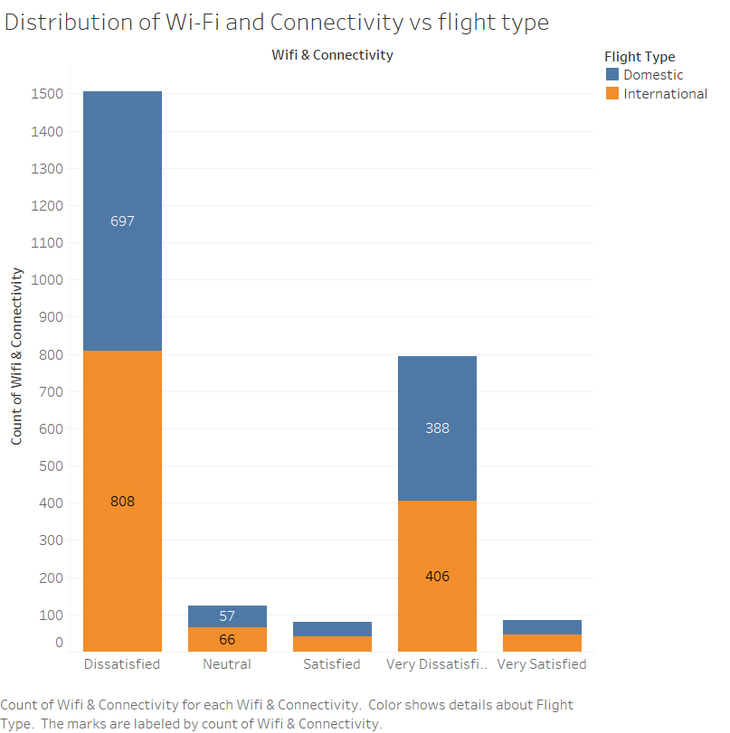

Figure 16

The x-axis represents the Wi-Fi and connectivity services satisfaction levels, and the y-axis represents the number of customers given that particular rating.

From this chart, we can see that most of the international and domestic customers have rated “Dissatisfied” for the flights. 697 customers were dissatisfied with Wi-Fi and connectivity in the domestic category, and 808 customers were very dissatisfied with Wi-Fi and connectivity in the international category.

## **TEXT PRE-PROCESSING:**

Text preprocessing is crucial in sentiment analysis and in many other Natural Language Processing (NLP) tasks. It involves cleaning and preparing text data for analysis to improve the accuracy and effectiveness of the subsequent processes. Social media posts, reviews, and other text sources, such as special characters, emoticons, and irrelevant punctuation, often contain noise. Removing or standardizing these elements helps to reduce the complexity of the data and focus on the meaningful content.

**To achieve this, we have implemented 3 important steps:**

Tokenization, stop word removal, and stemming.

**Tokenization:**

This is the process of breaking down text into individual words or tokens. Tokenization is essential because it determines the granularity of the analysis. For instance, "don't" might be tokenized into "do" and "not" to capture the sentiment of negation better.

**Stop Word Removal:**

Common words like "the", "is", and "at" may not carry significant sentiment and can be removed to reduce the dimensionality of the data. This allows the sentiment analysis model to focus on words that are more likely to convey sentiment.

**Stemming:**

These processes reduce words to their root form. For example, "running", "runs", and "ran" might all be reduced to the base form "run". This helps consolidate the analysis around the word's core meaning rather than its grammatical variations.

Below is an example of how the original review text has changed after implementing text preprocessing on it.

**Original Text:**

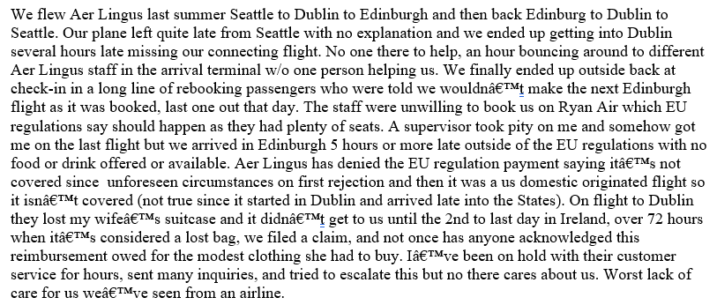

**Preprocessed Text:**

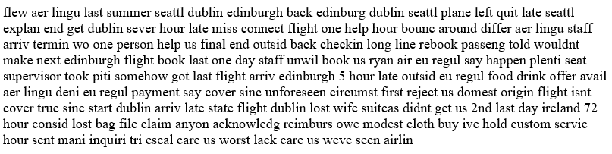

This process was implemented on the “Review” column, which contains the original text of the reviews the customers gave. A new column, “Preprocessed Reviews,” was created, which contains the preprocessed text of all the original reviews.

**IMPLEMENTING SENTIMENT METHODOLOGIES:**

To compute the sentiment from the preprocessed text of the reviews, we have implemented two techniques and will provide the contrast in the sentiment scores generated from these two methods.

**Valence Aware Dictionary and Sentiment Reasoner (VADER):**

Is a lexicon and rule-based sentiment analysis tool that is specifically attuned to sentiments expressed in social media. It is widely used for text sentiment analysis because it is sensitive to both the polarity (positive/negative) and the intensity (strength) of emotions.

VADER is open source and is available in the Python Natural Language Toolkit (NLTK). It can be used and adapted for various sentiment analysis tasks.

Implementing the VADER SentimentIntensityAnalyzer() class on the preprocessed review text generates the polarity scores for each review and a compound score representing the text's overall sentiment into the SentimentIntensityAnalyzer(). All these scores are numerical.

**Negative:** A float in the range [0, 1] representing the proportion of the text that falls into the negative sentiment category.

**Neutral:** A float in the range [0, 1] indicating the proportion of the neutral text (neither clearly positive nor negative).

**Positive:** A float in the range [0, 1] showing the proportion of the text that falls into the positive sentiment category.

**Compound**: A normalized, weighted composite score. This is the most useful metric if you want a single unidimensional measure of sentiment for a given text. The compound score ranges from -1 (most extreme negative) to +1 (most extreme positive).

The compound score is computed by summing the valence scores of each word in the lexicon, adjusted according to rules, and then normalized to be between -1 and 1.

Based on this, we have only considered the compound score for analyzing the sentiment and portraying its contrast across International and Domestic flights.

Below is the compound score of a preprocessed review text from our dataset using the **VADER lexicon:**





## **Text Blob**

## TextBlob is a popular Python library for processing textual data. It is straightforward to use and provides easy access to common text-processing tasks such as part-of-speech tagging, noun phrase extraction, and sentiment analysis. Here are some key points about using TextBlob for sentiment analysis:

**Simplicity and Accessibility:** One of the main advantages of TextBlob is its simplicity. It has a user-friendly interface that makes it accessible for beginners and useful for quick prototyping. You can perform sentiment analysis with just a few lines of code.

**Sentiment Analysis Features:** TextBlob can analyze text sentiment using a built-in sentiment analyzer. It provides two properties: polarity and subjectivity.

Polarity: This is a float within the range [-1.0, 1.0], where -1.0 is very negative, 1.0 is very positive, and 0 is neutral. It indicates the emotional meaning of the text.

**Subjectivity:** This is a float within the range [0.0, 1.0], where 0.0 is objective and 1.0 is subjective. Subjective sentences generally refer to personal opinions, emotions, or judgments.

**Underlying Mechanisms:** The default sentiment analyzer in TextBlob is based on a lexicon of pre-scored words. Each word in the lexicon has scores for polarity and subjectivity. The sentiment of a text is the aggregate of these scores.

We only used the Polarity generated from implementing TextBlob on the preprocessed review text.





We can see the contrast between the sentiment scores generated from VADER and TextBlob on the same piece of review text.

**CORRELATION BETWEEN VADER AND TEXTBLOB:**

We computed the Pearson correlation coefficient between the two sentiment scores generated from these methodologies.

The value of the **Pearson correlation coefficient** is **0.5543620636161801**.

A Pearson correlation coefficient of 0.5543620636161801 between the VADER compound score and TextBlob polarity score indicates a moderate positive linear relationship between these two sentiment measures.

**Positive Relationship:** Since the coefficient is positive, it suggests that as the VADER compound score increases (indicating more positive sentiment), the TextBlob polarity score also tends to increase (also indicating more positive sentiment), and vice versa. In other words, when one score suggests a positive sentiment, the other score is likely to also suggest a positive sentiment, and similarly for negative sentiments.

**Moderate Correlation:** The value of 0.554 is considered a moderate correlation in statistical terms. This implies that while there is a relationship between the two scores, it is not extremely strong. A significant amount of variability is not shared between the two scores. This is not unusual since VADER and TextBlob use different algorithms and methodologies to assess sentiment. VADER is specifically tuned for social media text and incorporates things like emojis and slang, while TextBlob uses a more general lexicon-based approach.

**Practical Implications:** For practical purposes, this correlation suggests that while VADER and TextBlob sentiment scores are aligned to some extent, they are not interchangeable. They might give similar sentiments on many occasions but can differ in others. This can be due to the nuances of language, different handling of context, sarcasm, negation, etc., in their respective algorithms.

In summary, a Pearson correlation coefficient of about 0.554 indicates a moderate positive relationship, suggesting that VADER and TextBlob often but not always agree on the sentiment of a text.

**RESEARCH QUESTIONS**:

For answering our research questions, we used a new dataset “vadertextblob.csv” which has the preprocessed review text, compound score from VADER, polarity score from TextBlob, category labels of sentiment generated from compound score of VADER and category labels of sentiment generated from the polarity score of TextBlob.

1. Airline Name: Names of the various Airlines in the dataset.
2. Overall_Rating: Rating given by a customer for that flight (0-9).
3. Review_Title: Title of the review given by the customer for that flight.
4. Review: Text of the review.
5. Type Of Traveler: Description about the type of the traveler (E.g., Solo or leisure or family etc.)
6. Seat Type: The type of seat the traveler has travelled in (E.g., Economy, or Business etc.)
7. Date Flown: Departure date of the flight.
8. Seat Comfort: Contains 5 levels of satisfaction based on the ratings given.
9. Cabin Staff Service: Contains 5 levels of satisfaction based on the ratings given.
10. Food & Beverages: Contains 5 levels of satisfaction based on the ratings given.
11. Ground Service: Contains 5 levels of satisfaction based on the ratings given.
12. Inflight Entertainment: Contains 5 levels of satisfaction based on the ratings given.
13. Wi-fi & Connectivity: Contains 5 levels of satisfaction based on the ratings given.
14. departure: Has the departure cities.
15. destination: Has the destination cities
16. in_usa: Has true or false values. Referencing the departure column. TRUE if departure city is in USA.
17. destination_country: Refers to the cities in the destination column, contains the country of that city.
18. destination_in_USA: Contains TRUE or FALSE values. Refers to the destination_country and gives TRUE if the country is United States.
19. flight_type: Has values International and Domestic
20. Preporcessed_Reviews: Column contains the preprocessed review text.
21. Compound_vader: The compound score generated from Vader for each preprocessed review.
22. Sentiment_tb: The polarity score for each review generated from TextBlob.
23. category_tb: The categorical sentiment labels for “Sentiment_tb”.
24. category_vader: The categorical sentiment labels for “Compound_vader”.

**Question 1:**

**How do the sentiment scores generated from Vader and TextBlob change over the years among domestic and international flights? What can we make out of it?**

Let's explore the seasonality of sentiment generated from VADER:

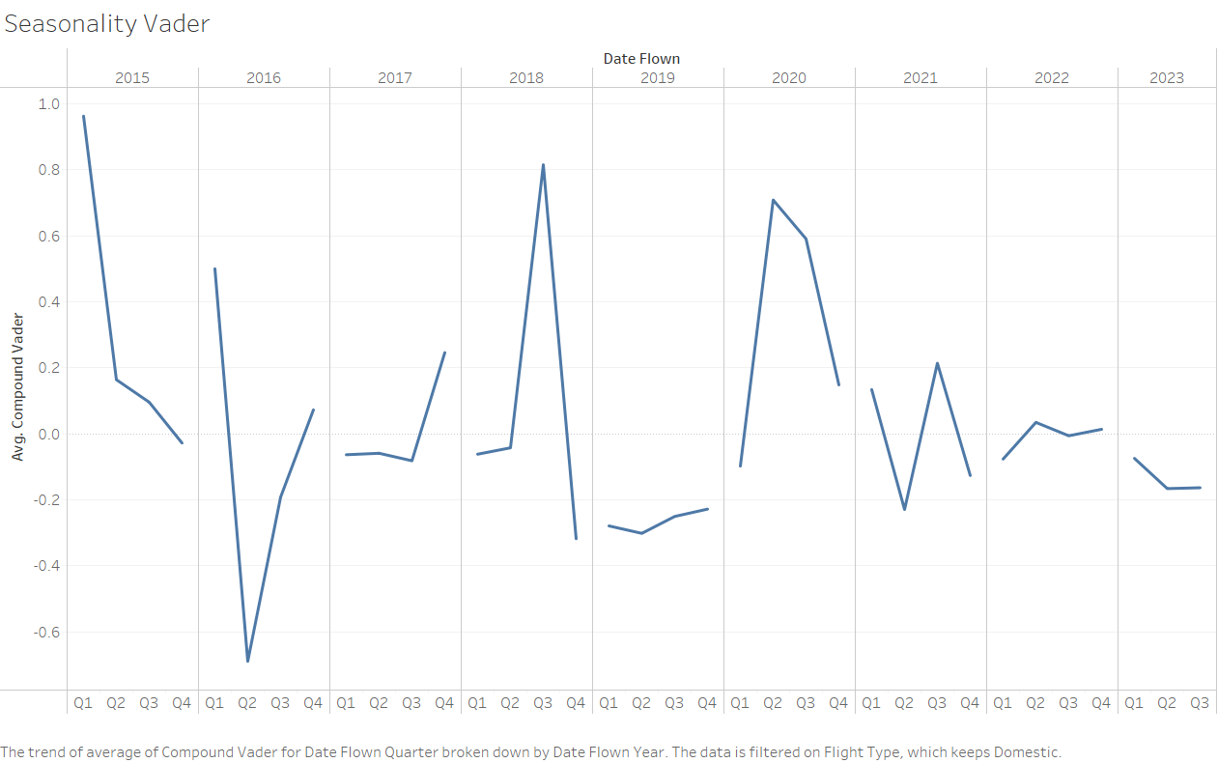

Figure 17

This line graph shows the seasonality of the sentiment score generated using VADER over the quarters of the years from 2015 to 2023 across domestic airlines.

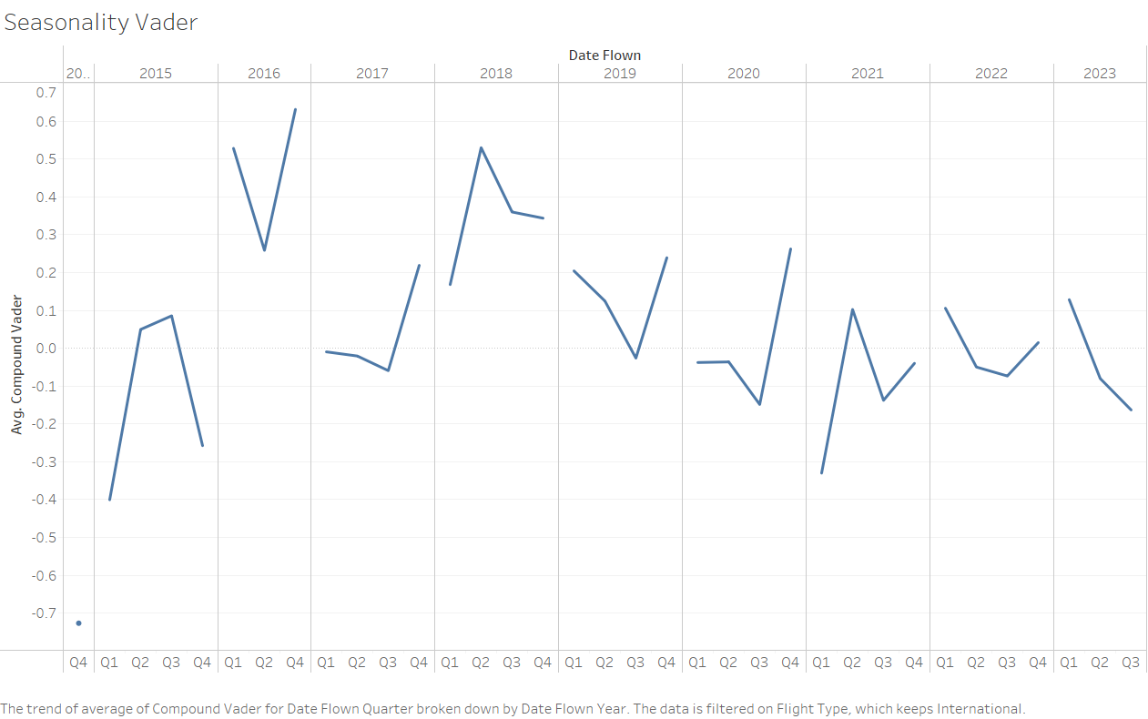

Figure 18

This line graph shows the seasonality of the sentiment score generated using VADER over the quarters of the years from 2015 to 2023 across international airlines.

**Insights from the seasonal distribution of VADER compound score:**

**Domestic Flights**:

**Volatility**: The sentiment scores for domestic flights exhibit volatility over the years. The scores fluctuate significantly from one quarter to the next, indicating inconsistent passenger experiences or variations in expectations and perceptions over time.

**Negative Troughs**: There are noticeable troughs where sentiment dips into the negative, particularly sharp in early 2015 and less so in early 2020.

**Positive Peaks**: Conversely, there are periods where sentiment peaks positively. Notably, mid-2015, late 2016, and mid-2019 show relatively high sentiment scores.

**Trending Downward in 2020**: There is a clear downward trend at the beginning of 2020, likely reflecting the onset of the COVID-19 pandemic and its impact on travel experiences.

**Recovery Post-2020**: After the initial drop in 2020, there is a recovery pattern, but not to the levels seen in previous years, suggesting a lasting impact of the pandemic on passenger sentiment.

**International Flights**:

**Less Volatility**: Compared to domestic flights, international flight sentiment scores are less volatile, with smoother transitions between quarters.

**Consistently Low Periods**: There are periods where sentiment remains consistently low, notably in early 2017 and throughout 2020.

**Gradual Improvement Post-2020**: After a substantial drop in 2020, there is a noticeable gradual improvement, suggesting adaptation or improved satisfaction with international travel conditions post-pandemic.

**Mid-Year Peaks**: There is a tendency for sentiment to peak during the middle of the year, possibly coinciding with summer travel or holiday seasons.

**Overall Higher Sentiment**: The average sentiment for international flights seems to be higher than domestic, indicated by fewer and less severe negative dips.

**General Observations for Both**:

**Impact of External Factors**: The sentiment scores are likely influenced by external factors such as seasonal travel patterns, economic conditions, and global events like the COVID-19 pandemic.

**Seasonal Patterns**: Both domestic and international flights show some seasonality in sentiment, with mid-year often showing higher sentiment scores.

**Pandemic Influence**: Both charts illustrate the impact of the COVID-19 pandemic, with a notable dip in sentiment scores corresponding to the onset of global travel restrictions and health concerns in early 2020.

Let's explore the seasonality of sentiment generated from TextBlob:

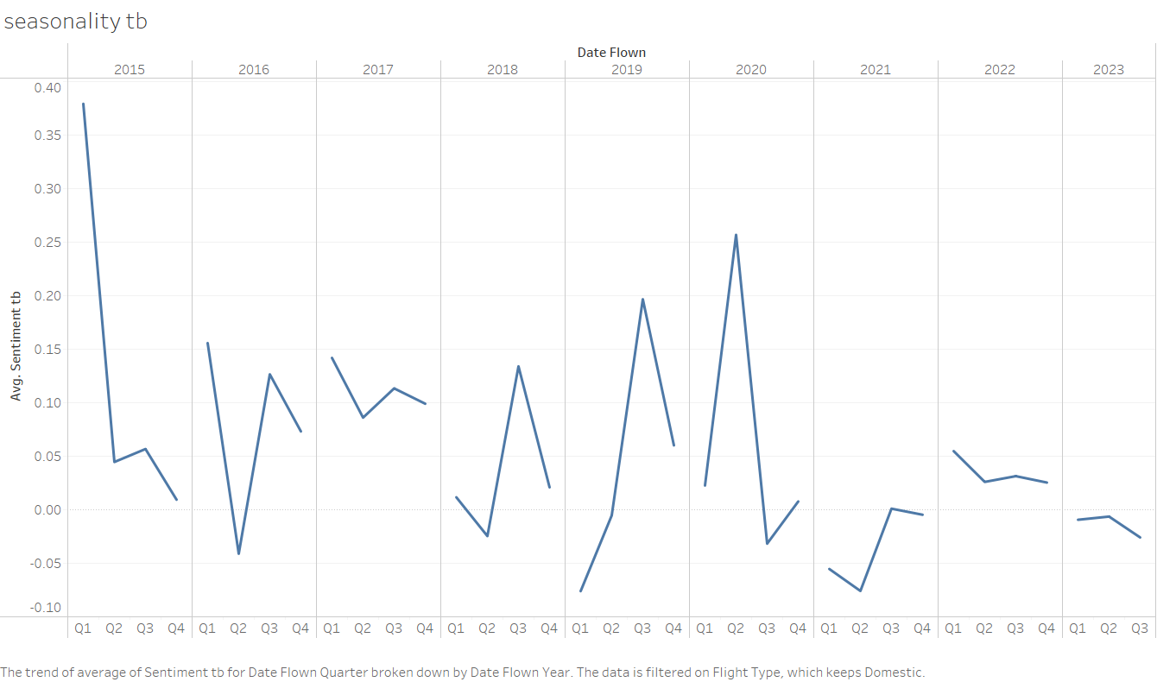

Figure 19

This line graph shows the seasonality of the sentiment score generated using TextBlob over the quarters of the years from 2015 to 2023 across domestic airlines.

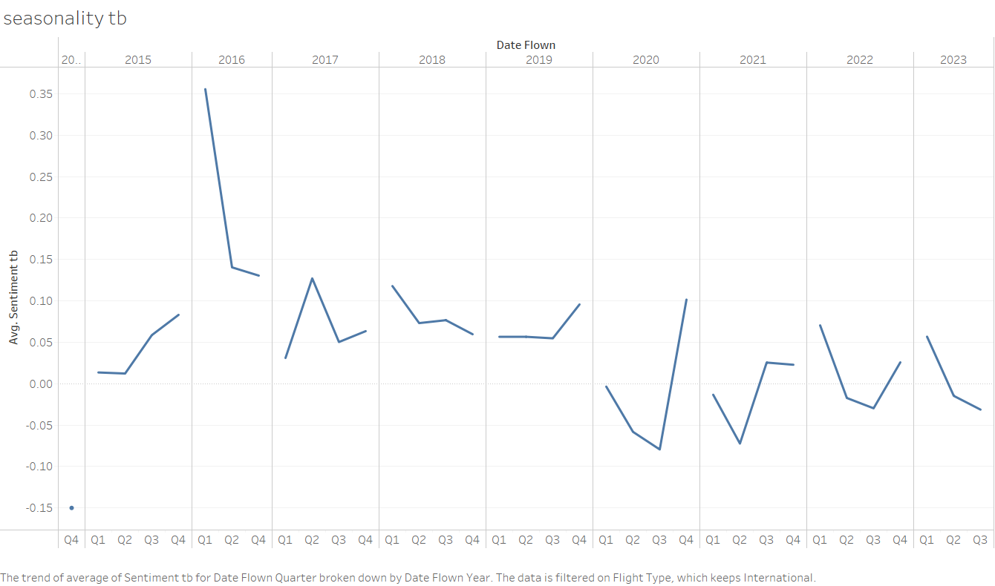

Figure 20

This line graph shows the seasonality of the sentiment score generated using TextBlob over the quarters of the years from 2015 to 2023 across international airlines.

**Insights from the seasonal distribution of TextBlob polarity score:**

**Domestic Flights**:

**Overall Positive Trend**: The polarity scores for domestic flights are mostly above zero, indicating a generally positive sentiment.

**Significant Fluctuations**: There are notable fluctuations in sentiment scores, with sharp increases and decreases between quarters. This could suggest seasonal impacts or specific events affecting passenger sentiment.

**Recovery Phases**: After notable dips, such as those in early 2015 and 2020, there are periods of recovery where the sentiment improves markedly in subsequent quarters.

**Recent Stability**: The most recent years, particularly post-2020, show less volatility and more stable, but lower positive sentiment scores, possibly indicating an adjustment to new norms in travel.

**International Flights**:

**Less Positive Sentiment**: Compared to domestic flights, international flights have lower polarity scores, hovering closer to zero, which indicates a more neutral sentiment overall.

**Consistent Seasonal Patterns**: Like the VADER analysis, there are consistent patterns where sentiment peaks and troughs, possibly aligned with holiday seasons or other regular events in the travel calendar.

**Pandemic Impact**: The year 2020 shows a clear negative impact on sentiment scores, which is likely due to the COVID-19 pandemic. However, the recovery in sentiment seems quicker and more pronounced compared to domestic flights.

**No Extreme Negatives**: Unlike the VADER sentiment scores, the TextBlob polarity scores do not show extreme negative values, suggesting that while passengers may have had negative experiences, their language remained more neutral than strongly negative.

**General Observations for Both**:

**Presence of Seasonality**: Both domestic and international flights show signs of seasonality in passenger sentiment, which can be valuable for airlines to anticipate changes in passenger experience and satisfaction.

**COVID-19 Impact**: The years 2020 and 2021 highlight the significant impact of the COVID-19 pandemic on passenger sentiment, with noticeable dips in both domestic and international sentiment during the early stages of the pandemic.

**Gradual Recovery Post-Pandemic**: There is an evident trend of recovery in sentiment scores post-2020, which may reflect the airline industry's adaptation to new health and safety protocols and passengers' reassessment of their travel experiences.

**Question 2:**

**What are the airlines that have a low sentiment generated from Vader among the domestic and international airlines? How can they improve their customers' experience?**

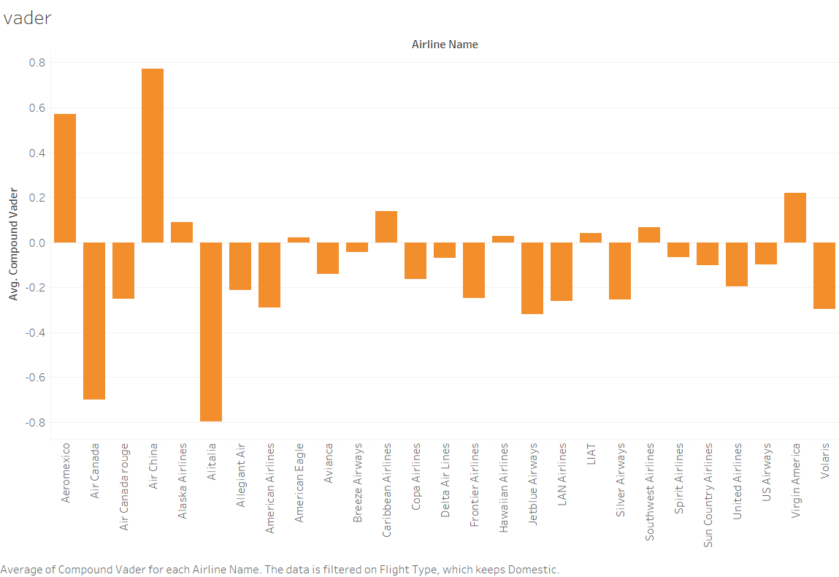

Figure 21

This distribution shows the variations of the **compound score** generated by **VADER** for the airlines in the **domestic category**. The x-axis has the airline names, and the y-axis has the average compound score from reviews for each airline. From this distribution, we extracted the names of airlines with the **lowest** average compound scores and those that satisfied the observation count for computing statistical proof on which we based our recommendations.

The airlines with the lowest average compound score that satisfies the observation count in the domestic category are.

**Frontier Airlines, Silver Airways, and Jetblue Airways.**

Statistical Proof for domestic airlines based on VADER compound score:

|  |  |  |  |  |
| --- | --- | --- | --- | --- |
| **Domestic** | | | | |
| **Airline Name** | **T-statistic** | **p-value** | **one tail p-value** | **result** |
| Frontier Airlines | -2.337898075 | 0.021785 | 0.010892534 | significant |
| Silver Airways | -2.410282864 | 0.018103 | 0.00905162 | significant |
| Jetblue Airways | -3.339151357 | 0.001279 | 0.00063972 | significant |

Table 1

In this scenario, our audience are airline businesses and giving them business recommendations based on just the exploratory data analysis of the sentiment scores generated from VADER is not enough, we decided to perform a **Welch’s T-test**. As our analysis verifies the direction between the two groups in comparison, we computed a **one-tailed t-test**, which generated a one-tailed p-value.

The two groups in comparison in these T-tests are.

**Group 1:** The average compound score of the airline we want to compare in the domestic airlines’ population.

**Group 2:** The average compound score of all the other airlines (except the one in Group 1) in the domestic airlines’ population.

**H0 (Null Hypothesis):** The average compound score of the specific airline is equal to or greater than the average compound score of all other airlines. This is a statement of no effect or no difference. It essentially posits that the specific airline does not have a lower average score compared to the others.

H0: u1>=u2

**H1 (Alternative Hypothesis):** The average compound score of the specific airline is less than the average compound score of all other airlines. This hypothesis is what we are testing for. It's a statement that suggests there is a difference, and specifically, that the specific airline has a lower average score.

The alternative hypothesis can be formally expressed as

H1: u1<u2

From the above table, if the result is “significant,” we reject the null hypothesis in favor of the alternate hypothesis and conclude that the average compound score of the airline is less than the other group with which we are comparing it against.

We provide recommendations to the airline businesses based on this statistical proof.

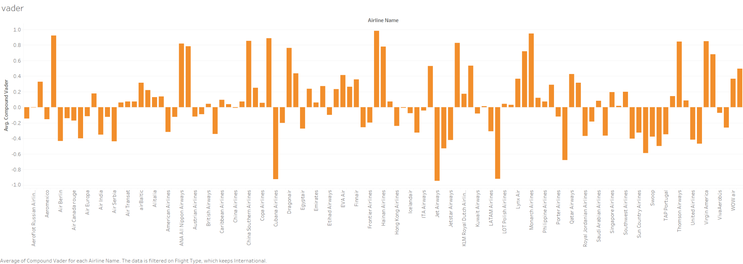

Figure 22

This distribution shows the variations of the **compound score** generated by **VADER** for the airlines in the **international category**. The x-axis has the airline names, and the y-axis has the average compound score generated from reviews for each airline. From this distribution, we extracted the names of airlines with the **lowest** average compound scores and those that satisfied the observation count for computing statistical proof on which we based our recommendations.

The airlines with the lowest average compound score that satisfies the observation count in the international category are.

**United Airlines, Royal Jordanian Airlines, and Interjet Airlines.**

Statistical Proof for international airlines based on VADER compound score:

|  |  |  |  |  |
| --- | --- | --- | --- | --- |
| **International** | | | | |
| **Airline Name** | **T-statistic** | **p-value** | **one tail p-value** | **result** |
| United Airlines | -4.140990195 | 0.000278 | 0.000138829 | significant |
| Royal Jordanian Airlines | -3.334113892 | 0.003006 | 0.00150287 | significant |
| Interjet Airlines | -3.615396056 | 0.000981 | 0.000490256 | significant |

Table 2

The two groups in comparison in these T-tests are:

**Group 1:** The average compound score of the airline we want to compare in the international airlines’ population.

**Group 2:** The average compound score of all the other airlines (except the one in Group 1) in the international airlines’ population.

**H0 (Null Hypothesis):** The average compound score of the specific airline is equal to or greater than the average compound score of all other airlines. This is a statement of no effect or no difference. It essentially posits that the specific airline does not have a lower average score compared to the others.

H0: u1>=u2

**H1 (Alternative Hypothesis):** The average compound score of the specific airline is less than the average compound score of all other airlines. This hypothesis is what we are testing for. It's a statement that suggests there is a difference, and specifically, that the specific airline has a lower average score.

The alternative hypothesis can be formally expressed as

H1: u1<u2

From the above table, if the result is “significant,” we reject the null hypothesis in favor of the alternate hypothesis and conclude that the average compound score of the airline is less than the other group with which we are comparing it against.

We provide recommendations to the airline businesses based on this statistical proof.

**Question 3:**

**What are the airlines that have a low sentiment generated from TextBlob among the domestic and international airlines? How can they improve their customers' experience?**

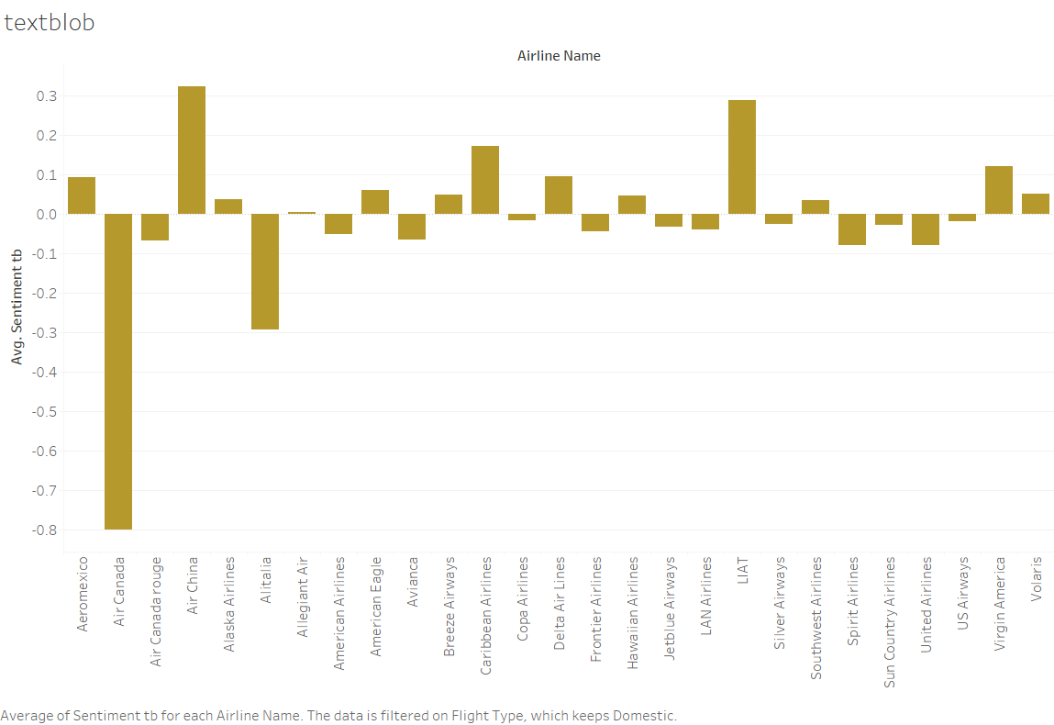

Figure 23

This distribution shows the variations of the **compound score** generated by **TextBlob** for the airlines in the **domestic category**. The x-axis has the airline names, and the y-axis has the average polarity score from reviews for each airline. From this distribution, we extracted the names of airlines with the lowest average polarity scores and those that satisfied the observation count for computing statistical proof on which we based our recommendations.

The airlines with the **lowest** average TextBlob compound score that satisfies the observation count in the domestic category are.

**American Airlines, Spirit Airlines, and United Airlines.**

Statistical Proof for domestic airlines based on TextBlob polarity score:

|  |  |  |  |  |
| --- | --- | --- | --- | --- |
| **Domestic** | | | | |
| **Airline Name** | **T-statistic** | **p-value** | **one tail p-value** | **result** |
| American Airlines | -2.79001603 | 0.006596 | 0.003297829 | significant |
| Spirit Airlines | -3.068540452 | 0.002811 | 0.001405262 | significant |
| United Airlines | -2.403559328 | 0.019203 | 0.009601252 | significant |

Table 3

The two groups in comparison in these T-tests are.

**Group 1:** The average polarity score of the airline we want to compare in the domestic airlines population.

**Group 2:** The average polarity score of all the other airlines (except the one in Group 1) in the domestic airlines population.

**H0 (Null Hypothesis):** The average polarity score of the specific airline is equal to or greater than the average polarity score of all other airlines.

H0: u1>=u2

**H1 (Alternative Hypothesis):** The average polarity score of the specific airline is less than the average compound score of all other airlines. This hypothesis is what we are testing for.

The alternative hypothesis can be formally expressed as

H1: u1<u2

From the above table, if the result is “significant,” we reject the null hypothesis in favor of the alternate hypothesis and conclude that the average polarity score of the airline is less than the other group with which we are comparing it against.

We provide recommendations to the airline businesses based on this statistical proof.

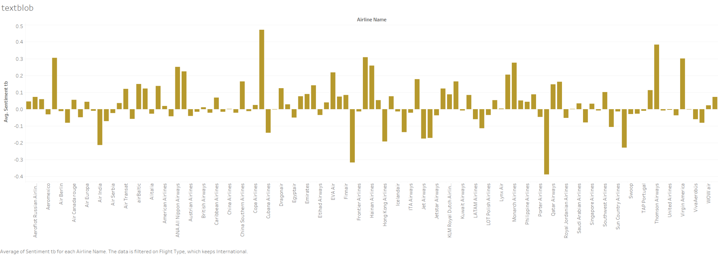

Figure 24

This distribution shows the variations of the **compound score** generated by **TextBlob** for the airlines in the **international category**. The x-axis has the airline names, and the y-axis has the average polarity score from reviews for each airline. From this distribution, we extracted the names of airlines with the lowest average polarity scores and those that satisfied the observation count for computing statistical proof on which we based our recommendations.

The airlines with the lowest average TextBlob polarity score that satisfies the observation count in the international category are:

**Jetblue Airways, Volaris, and Interjet Airlines.**

Statistical Proof for international airlines based on TextBlob polarity score:

|  |  |  |  |  |
| --- | --- | --- | --- | --- |
| **International** | | | | |
| **Airline Name** | **T-statistic** | **p-value** | **one tail p-value** | **result** |
| Jetblue Airways | -3.610395677 | 0.00393 | 0.001964992 | significant |
| Volaris | -1.608098908 | 0.122484 | 0.061242245 | not significant |
| Interjet Airlines | -3.295259248 | 0.002409 | 0.001204717 | significant |

Table 4

The two groups in comparison in these T-tests are:

**Group 1:** The average polarity score of the airline we want to compare in the international airlines’ population.

**Group 2:** The average polarity score of all the other airlines (except the one in Group 1) in the international airlines’ population.

**H0 (Null Hypothesis):** The average polarity score of the specific airline is equal to or greater than the average polarity score of all other airlines.

H0: u1>=u2

**H1 (Alternative Hypothesis):** The average polarity score of the specific airline is less than the average compound score of all other airlines. This hypothesis is what we are testing for.

The alternative hypothesis can be formally expressed as

H1: u1<u2

From the above table, if the result is “significant,” we reject the null hypothesis in favor of the alternate hypothesis and conclude that the average polarity score of the airline is less than the other group with which we are comparing it.

We provide recommendations to the airline businesses based on this statistical proof.

**Recommendations for Airlines from Questions 2 and 3:**

**For Domestic Airlines:**

**From VADER: Frontier Airlines, Silver Airways, and Jetblue Airways**

**From TextBlob: American Airlines, Spirit Airlines, and United Airlines**

**Enhanced Customer Service Training:**

Establish consistent, comprehensive training programs emphasizing empathy, patience, and good communication for all front-line employees, including check-in, gate agents, and cabin crew. Organize training sessions on how to deal with challenging circumstances and control passenger expectations, particularly when there are delays or cancellations.

**Frequent and Transparent Communication:**

Develop a proactive communication strategy, where passengers are promptly informed about any changes regarding their flights via SMS, email, and airline apps.

Integrate real-time updates within the airline's mobile app and website, offering passengers easy access to the latest information.

**Improved In-Flight Comfort and Amenities:**

Upgrade or maintain aircraft interiors to ensure clean, comfortable seating with adequate legroom. Evaluate and enhance in-flight entertainment options, including Wi-Fi, movies, and music, to cater to a variety of preferences. Consider offering complimentary snacks or beverages, even on shorter flights, as a gesture of goodwill.

**Loyalty and Reward Programs:**

Design loyalty programs with tangible and attractive benefits, such as free checked bags, priority boarding, or occasional complimentary upgrades.

Ensure that earning and redeeming points or rewards is straightforward and user-friendly.

**Streamlined Check-In and Boarding Processes:**

Invest in technology to enable smoother check-ins (like self-service kiosks and mobile check-in options). Optimize boarding procedures to minimize bottlenecks and delays, potentially adopting strategies like boarding by seat rows or zones.

**Flexible Booking and Cancellation Policies:**

Offer more flexible fares with transparent, easy-to-understand terms and conditions.

Simplify the process for making changes to bookings and requesting refunds to enhance customer trust and satisfaction.

**For International Airlines:**

**From VADER: United Airlines, Royal Jordanian Airlines, Interjet Airlines.**

**From TextBlob: Jetblue Airways, Interjet Airlines.** The T-test on **Volaris** was proven to be insignificant. Hence we will **not be providing** recommendations to that business as our statistical proof is not aligning with our intentions.

**Comfortable Long-Haul Experience:**

Focus on providing extra comfort in seating, such as more legroom, adjustable headrests, and ergonomic designs, especially for long-duration flights. Regularly review and upgrade in-flight meal quality, offering a range of options, including special dietary and cultural preferences.

**Multilingual Staff and Cultural Sensitivity:**

Hire and train cabin crew who can speak multiple languages, helping to break down language barriers with passengers from diverse backgrounds. Incorporate cultural sensitivity training, ensuring staff are aware of and respectful towards different cultural norms and practices.

**Efficient Baggage Handling and Customs Support:**

Invest in reliable and advanced baggage handling systems to ensure timely loading and unloading of luggage. Provide clear information and assistance for customs procedures and explore partnerships with airports to facilitate smoother transitions through customs and immigration.

**Robust In-Flight Entertainment System:**

Offer a diverse range of entertainment options, including movies, TV shows, music, and games in various languages. Regularly update the content to keep it fresh and engaging for frequent travelers.

**Comprehensive Transit and Connection Support:**

Provide detailed information and assistance for passengers with connecting flights, including maps, transit visa information, and minimum connection times.

Offer services like transit hotels or lounges for passengers with long layovers.

**Enhanced Health and Safety Measures:**

Maintain high standards of cleanliness and hygiene on board, including regular disinfection of high-touch areas. Implement and clearly communicate health and safety policies, such as mandatory mask-wearing or health screenings, depending on current health advisories.

For **questions 4 and 5,** we converted categorical satisfaction levels back into **numerical ratings**, as this enables a more robust statistical validation of our findings.

**Question 4:**

**How are the flights performing according to the satisfaction score given by the travelers for the departments that are crucial during a flight?**

The departments that are crucial during a flight in our dataset are Seat Comfort, Inflight Entertainment, Food and Beverages, Cabin Staff Service, Wi-Fi and Connectivity**.**

**Seat Comfort Department:**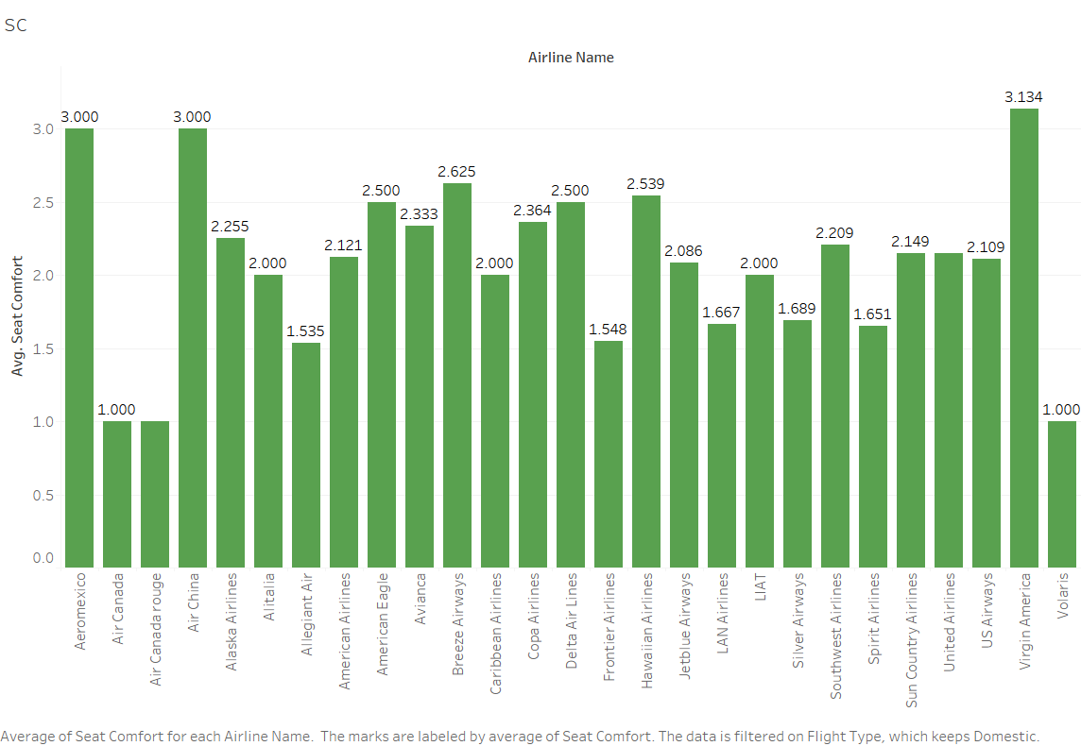

Figure 25

The above distribution shows the average **satisfaction scores** given by the customers in the seat comfort department for airlines in the **domestic category**. Y-axis represents the average satisfaction scores, and the x-axis represents the airline names. From this distribution, we extracted the airline's name with the **lowest** average satisfaction score for the seat comfort department and that which satisfies the observation count for computing statistical proof on which we based our recommendations for that airline.

The airline's name is **Allegiant Air**.

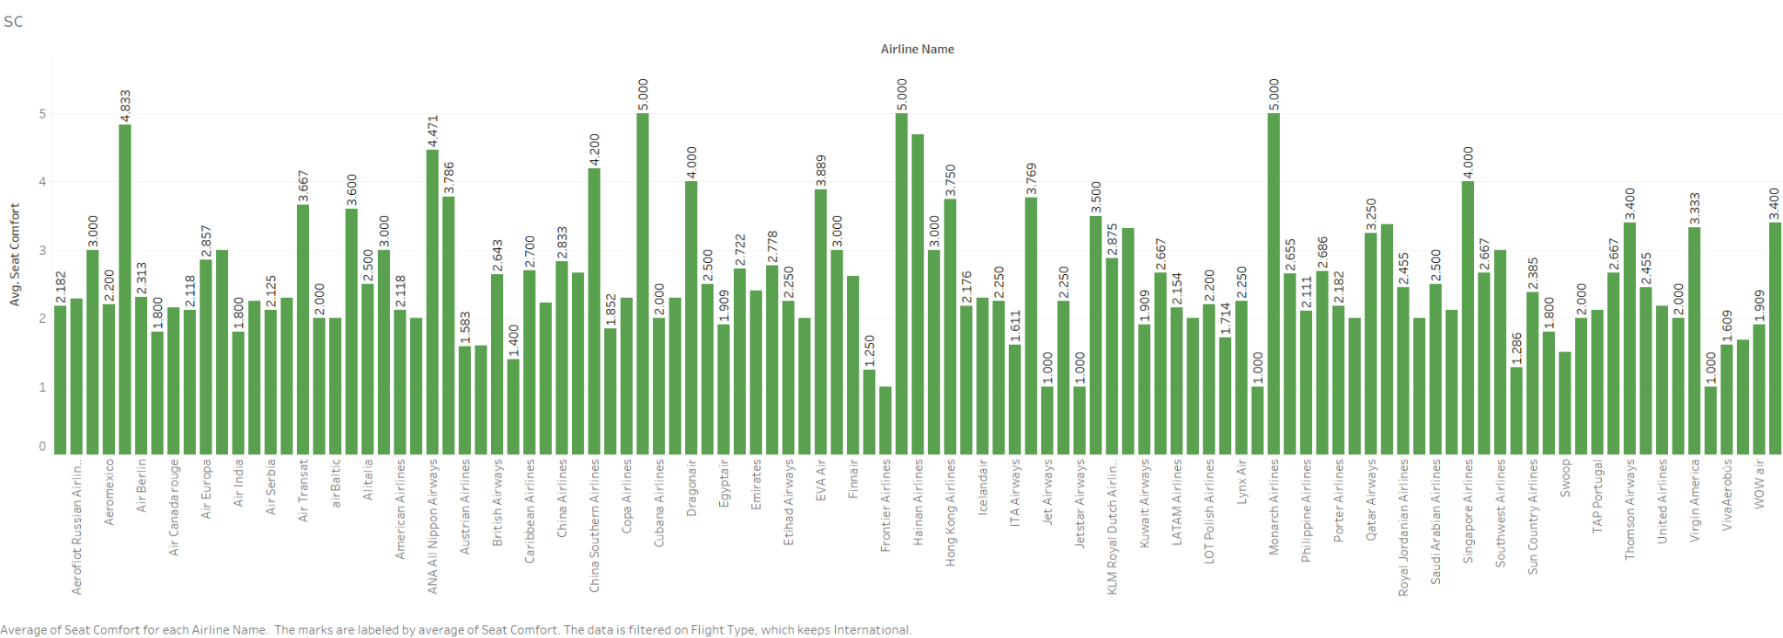

Figure 26

The above distribution shows the average **satisfaction scores** given by the customers in the seat comfort department for airlines in **the international category**. Y-axis represents the average satisfaction scores, and the x-axis represents the airline names. From this distribution, we extracted the airline's name with the **lowest** average satisfaction score for the seat comfort department and that which satisfies the observation count for computing statistical proof on which we based our recommendations for that airline.

The airline's name is **Jetblue Airways**.

**Statistical proof:**

|  |  |  |  |  |  |  |  |
| --- | --- | --- | --- | --- | --- | --- | --- |
| **Department Name** | **Flight Type** | **Air Line Name** | **Other Airlines Observations** | **T-test** | **P-Value** | **One-Tail P- Value** | **Result** |
| Seat Comfort | Domestic | Allegiant Air | 1133 | -6.1133 | 1.49E-08 | 7.43E-09 | Significant |
| Seat Comfort | International | Jetblue | 1357 | -0.47403 | 0.644 | 0.323 | Non-Significant |

For both International and domestic flight types in the seat comfort department.

Table 5

The two groups in comparison in these T-tests are:

**Group 1:** The average satisfaction score for the seat comfort department of the airline we want to compare in the international/domestic airlines population.

**Group 2:** The average satisfaction score for the seat comfort department of all the other airlines (except the ones in Group 1) in the international/domestic airlines population.

**H0 (Null Hypothesis):** The average satisfaction score for the seat comfort department of the specific airline(s) is equal to or greater than the average polarity score of all other airlines.

H0: u1>=u2

**H1 (Alternative Hypothesis):** The average satisfaction score for the seat comfort department of the specific airline(s) is less than the average compound score of all other airlines. This hypothesis is what we are testing for.

The alternative hypothesis can be formally expressed as

H1: u1<u2

From the above table, if the result is “significant,” we reject the null hypothesis in favor of the alternate hypothesis and conclude that the average satisfaction score for the seat comfort department of the airline(s) is less than the other group with which we are comparing it against.

We provide recommendations to the airline businesses based on this statistical proof.

**Recommendations for domestic:**

1. **Quick turnaround comfort upgrades:** While there may be constraints on options that could be offered to Domestic travelers, having a short turnaround time for repairs like replacing seat cushioning, worn out pillows, optimizing seat pitch, etc. can go a long way.
2. **Collaborate with experts:** On-boarding sleep experts and ergonomic seat designs can help create a better experience for the travelers. Sleep experts can help create an environment using all 5 senses to induce sleep during red-eye flights and orthopedic experts and ensure the best possible seat design is implemented in the space available.

**Recommendations for international:** The t-test conducted on **Jetblue** is proven to be non-significant. Hence, we will not be providing recommendations to this airline as our statistical proof is not aligning with our intention.

**Inflight Entertainment:**

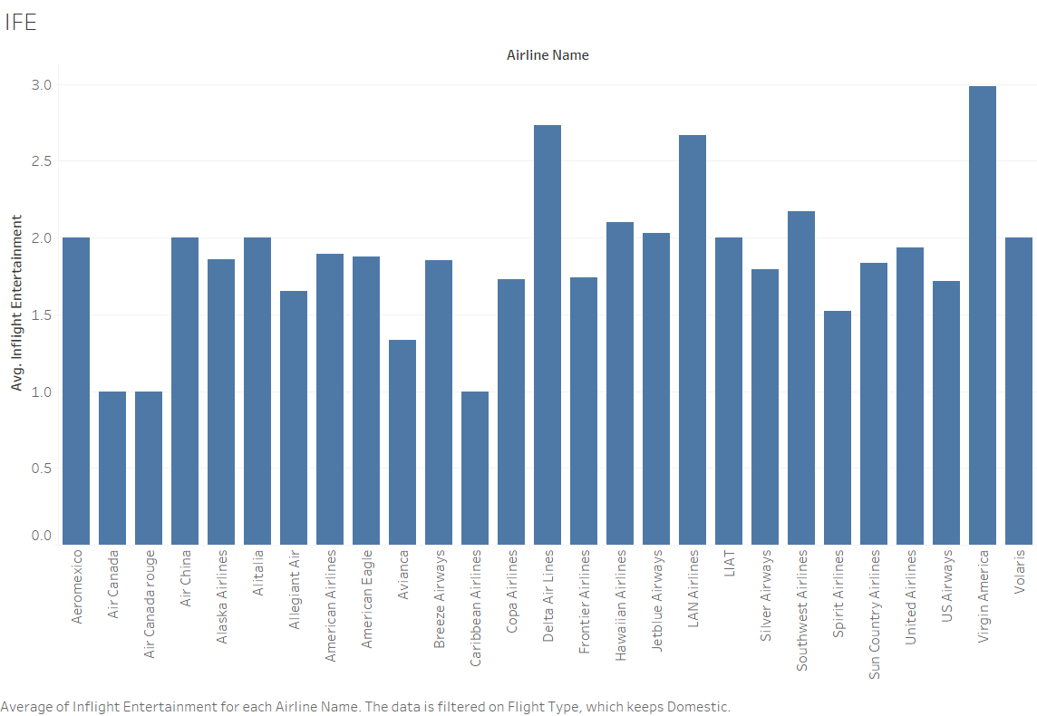

Figure 27

The above distribution shows the average **satisfaction scores** given by the customers in the inflight entertainment department for airlines in the **domestic category**. Y-axis represents the average satisfaction scores, and the x-axis represents the airline names. From this distribution, we extracted the airline's name with the **lowest** average satisfaction score for the inflight entertainment department and that which satisfies the observation count for computing statistical proof on which we based our recommendations for that airline.

The airline's name is **Spirit Airlines**.

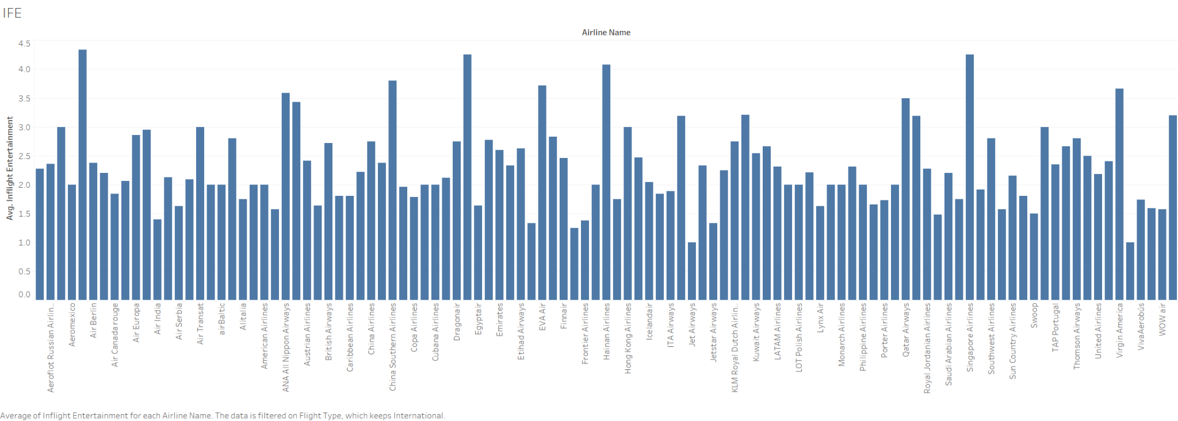

Figure 28

The above distribution shows the average **satisfaction scores** given by the customers in the inflight entertainment department for airlines in the **international category**. Y-axis represents the average satisfaction scores, and the x-axis represents the airline names. From this distribution, we extracted the airline's name with the lowest average satisfaction score for the inflight entertainment department and that which satisfies the observation count for computing statistical proof on which we based our recommendations for that airline.

The airline's name is **Flair Airlines**.

**Statistical proof:**

For both International and domestic flight types in the inflight entertainment department.

|  |  |  |  |  |  |  |  |
| --- | --- | --- | --- | --- | --- | --- | --- |
| **Department Name** | **Flight Type** | **Air Line Name** | **Other Airlines Observations** | **T-test** | **P-Value** | **One-Tail P- Value** | **Result** |
| Inflight Entertainment | Domestic | Spirit Airlines | 1133 | -7.769401 | 1.52E-12 | 7.61E-13 | Significant |
| Inflight Entertainment | International | Flair Airlines | 1356 | -4.08741 | 0.0247 | 0.0123 | Significant |

Table 6

The two groups in comparison in these T-tests are:

**Group 1:** The average satisfaction score for the inflight entertainment department of the airline we want to compare in the **international/domestic** airlines population.

Group 2: The average satisfaction score for the inflight entertainment department of all the other airlines (except the ones in Group 1) in the **international/domestic** airlines population.

**H0 (Null Hypothesis):** The average satisfaction score for the inflight entertainment department of the specific airline(s) is equal to or greater than the average satisfaction score of all other airlines.

H0: u1>=u2

**H1 (Alternative Hypothesis):** The average satisfaction score for the inflight entertainment department of the specific airline(s) is less than the average satisfaction score of all other airlines. This hypothesis is what we are testing for.

The alternative hypothesis can be formally expressed as

H1: u1<u2

From the above table, if the result is “significant,” we reject the null hypothesis in favor of the alternate hypothesis and conclude that the average satisfaction score for the inflight entertainment department of the airline(s) is less than the other group with which we are comparing it against.

We provide recommendations to the airline businesses based on this statistical proof.

**Recommendations for domestic**:

**Regional Content Selection:**  
A curated list of songs, shows, documentaries that help passengers get exposure to the regional content. This also bodes well with passengers who prefer consuming content in their regional language.

**Shorter Duration Content**:  
Since Domestic flights have shorter journeys, presenting bite sized content options would be more suitable. Selecting content according to the average flight time could reduce the load on the server where the content is being stored. For example, having 4-5 popular episodes from a recognized sit-com would be better than having 2-3 seasons of the show.

**Quick Turnaround Features**:

No one likes an inflight television where the fast-forward options do not work. We recommend airlines to invest in upgrading the in-flight entertainment systems to improve the overall experience for passengers.

**Cost effective options**:  
Considering domestic flight passengers may prioritize affordability during short duration flights, pay on demand movies and shows can be priced in a way to promote their purchases.

**Recommendations for international:**

**Diverse and Immersive Gaming Options:**

Forge partnerships with prominent gaming companies to broaden the range of gaming choices provided to passengers. From casual to competitive, these options will cater to diverse passenger demographics while offering multiplayer experiences for an interactive and engaging journey.

**Global Content and Variety:**A large selection of global content can be available for passengers of multiple backgrounds and nationalities to enjoy. We recommend providing international passengers with a variety of long and short duration content including documentaries, tv-shows, movie series, etc. They have the time to enjoy the content given the long duration of the flight.

**Exclusive Partnerships for Personalization:**  
While everyone today wants to create a personalized experience for their customers, we recommend airlines to partner up with prominent online entertainment providers like Netflix, Disney Plus (Hulu), Peacock, Spotify, etc. to directly allow passengers to log into their accounts and access content recommended to them. Such strategic partnerships can be leveraged using in-flight targeted advertisements and promotions which could benefit the airline.

**Food and Beverages:**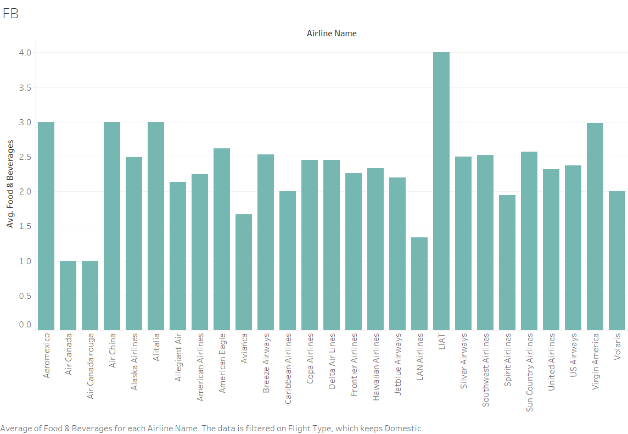

Figure 29

The above distribution shows the average **satisfaction scores** given by the customers in the food and beverages department for airlines in the **domestic category**. Y-axis represents the average satisfaction scores, and the x-axis represents the airline names. From this distribution, we extracted the airline's name with the lowest average satisfaction score for the food and beverages department and that which satisfies the observation count for computing statistical proof on which we based our recommendations for that airline.

The airline's name is **Spirit Airlines**.

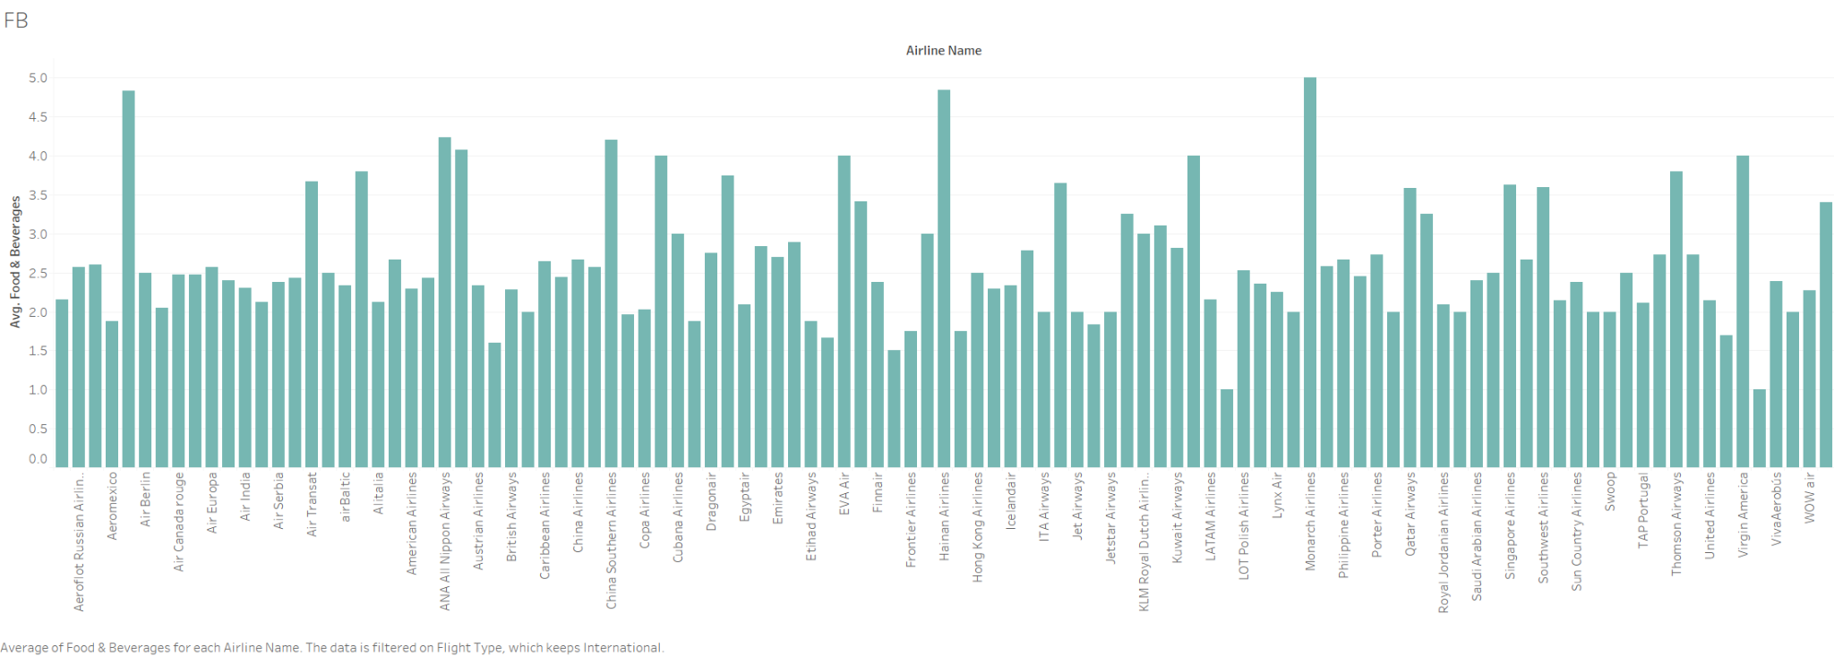

Figure 30

The above distribution shows the average **satisfaction scores** given by the customers in the food and beverages department for airlines in the **international category**. Y-axis represents the average satisfaction scores, and the x-axis represents the airline names. From this distribution, we extracted the airline's name with the **lowest** average satisfaction score for the food and beverages department and that which satisfies the observation count for computing statistical proof on which we based our recommendations for that airline.

The airline's name is **Avianca Airlines**.

**Statistical proof:**

For both International and domestic flight types in the food and beverages department.

|  |  |  |  |  |  |  |  |
| --- | --- | --- | --- | --- | --- | --- | --- |
| **Department Name** | **Flight Type** | **Air Line Name** | **Other Airlines Observations** | **T-test** | **P-Value** | **One-Tail P- Value** | **Result** |
| Food And Beverages | Domestic | Spirit Airlines | 1133 | -4.214248364 | 5.39E-05 | 2.70E-05 | Significant |
| Food And Beverages | International | Avianca | 1344 | -5.133687256 | 2.37E-05 | 1.19E-05 | Significant |

Table 7

The two groups in comparison in these T-tests are:

**Group 1:** The average satisfaction score for the food and beverages department of the airline we want to compare in the **international/domestic** airlines population.

**Group 2:** The average satisfaction score for the food and beverages department of all the other airlines (except the ones in Group 1) in the **international/domestic** airlines population.

**H0 (Null Hypothesis):** The average satisfaction score for the food and beverages department of the specific airline(s) is equal to or greater than the average satisfaction score of all other airlines.

H0: u1>=u2

**H1 (Alternative Hypothesis):** The average satisfaction score for the food and beverages department of the specific airline(s) is less than the average satisfaction score of all other airlines. This hypothesis is what we are testing for.

The alternative hypothesis can be formally expressed as

H1: u1<u2

From the above table, if the result is “significant,” we reject the null hypothesis in favor of the alternate hypothesis and conclude that the average satisfaction score for the food and beverages department of the airline(s) is less than the other group with which we are comparing it against.

We provide recommendations to the airline businesses based on this statistical proof.

**Recommendations for domestic:**

**Enhancing the Local Flavor:**

To enhance the overall travel experience, we recommend airlines to collaborate with local restaurants at destination airports. This partnership will provide domestic travelers with an introduction to the local cuisine, allowing them to savor the flavors of the region.

**Exclusive Dining for Premium Economy Passengers:**

For our premium economy passengers, we will develop exclusive dining packages. These packages will include priority service and a selection of exclusive beverages, further elevating the domestic flight experience for our valued customers.

**Catering to varied diets:**  
We recommend airlines to provide dining options for various diets including vegan, gluten free, dairy free, etc. These could be pre booked and the passengers with these requirements are usually comfortable with paying for the added service.

**Recommendations for international:**

**Wine-Pairing and Sommelier Services:**

To provide a sophisticated dining experience for our business class travelers on long-haul flights, we introduce wine-pairing events and onboard sommelier services. These offerings enhance the enjoyment of our premium cuisine by expertly matching it with the perfect wines.

**Collaboration with Renowned Chefs:**

We offer the opportunity to collaborate with world-renowned chefs to develop exclusive menus that showcase premium ingredients and innovative culinary concepts. This partnership aims to elevate the dining experience for passengers traveling on international flights.

**Cabin Staff Services:**

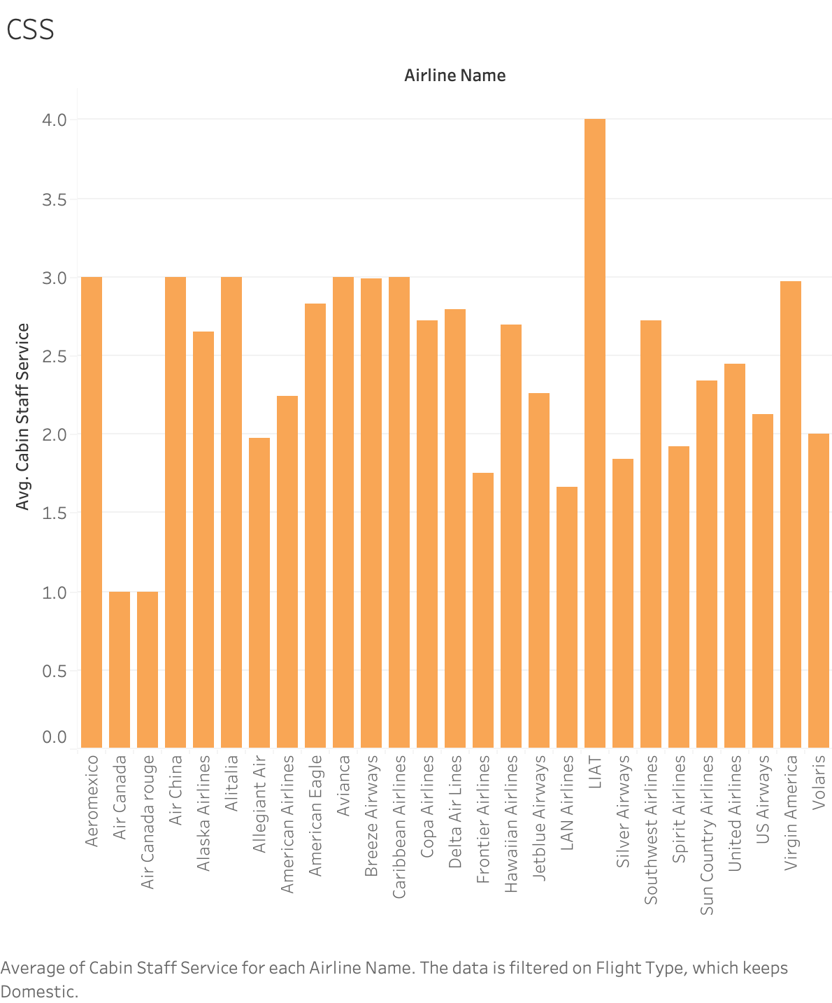

Figure 31

The above distribution shows the average **satisfaction scores** given by the customers in the Cabin staff services department for airlines in the **domestic category**. Y-axis represents the average satisfaction scores, and the X-axis represents the airline names. From this distribution, we extracted the name of the airline with the **lowest average** satisfaction score for the Cabin staff services department and that which satisfies the observation count for computing statistical proof on which we based our recommendations for that airline.

The airline's name is **Silver Airways**.

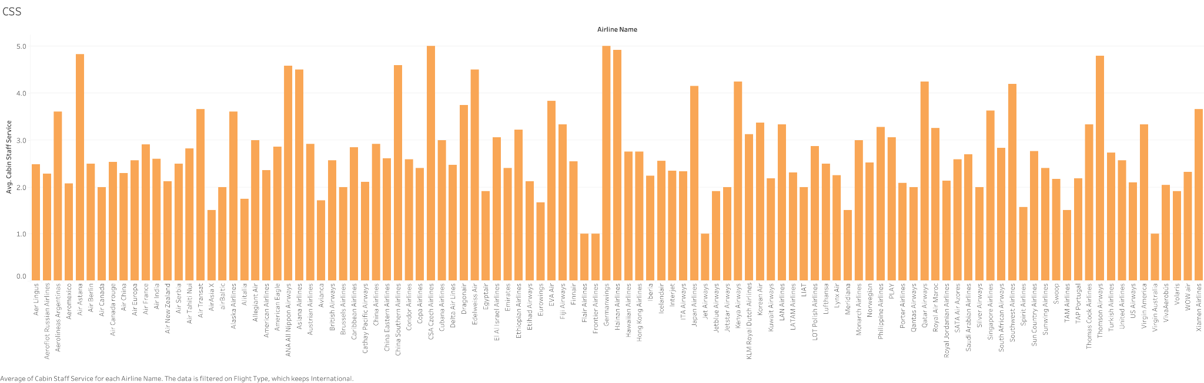

Figure 32

The above distribution shows the average **satisfaction scores** given by the customers in the Cabin staff services department for airlines in the **international category**. Y-axis represents the average satisfaction scores, and the x-axis represents the airline names. From this distribution, we extracted the airline's name with the **lowest** average satisfaction score for the Cabin staff services department and that which satisfies the observation count for computing statistical proof on which we based our recommendations for that airline.

The airline's name is **Frontier Airways**.

**Statistical proof:**

For both International and domestic flight types in the Cabin staff services department.

|  |  |  |  |  |  |  |  |
| --- | --- | --- | --- | --- | --- | --- | --- |
| **Department Name** | **Flight Type** | **Air Line Name** | **Other Airlines Observations** | **T-test** | **P-Value** | **One-Tail P- Value** | **Result** |
| Cabin Staff Service | Domestic | Silver Airways | 1145 | -4.0689073 | 0.0001 | 5.20E-05 | Significant |
| Cabin Staff Service | International | Frontier Airlines | 1361 | -42.54500403 | 3.43E-252 | 1.72E-252 | Significant |

Table 8

The two groups in comparison in these T-tests are:

**Group 1:** The average satisfaction score for the cabin staff services department of the airline we want to compare in the **international/domestic** airlines population.

**Group 2**: The average satisfaction score for the cabin staff services department of all the other airlines (except the ones in Group 1) in the **international/domestic** airlines population.

H0 (Null Hypothesis): The average satisfaction score for the cabin staff services department of the specific airline(s) is equal to or greater than the average satisfaction score of all other airlines.

H0: u1>=u2

**H1 (Alternative Hypothesis):** The average satisfaction score for the cabin staff services department of the specific airline(s) is less than the average satisfaction score of all other airlines. This hypothesis is what we are testing for.

The alternative hypothesis can be formally expressed as

H1: u1<u2

From the above table, if the result is “significant,” we reject the null hypothesis in favor of the alternate hypothesis and conclude that the average satisfaction score for the cabin staff services department of the airline(s) is less than the other group with which we are comparing it against.

We provide recommendations to the airline businesses based on this statistical proof.

**Recommendations for domestic:**

**Flash giveaways and contests:**

Conduct in-flight contests with instant digital prizes, like discount codes for future flights, upgrades, or vouchers for airport concessions. Trivia Contests can be games related to travel, geography, or aviation. Passengers can participate through the in-flight entertainment system, or a mobile app. Winners could receive instant prizes like discounts on future flights or extra frequent flyer miles. Flight Feedback Rewards can be offers or rewards, like a voucher or discount, to a randomly selected passenger who completes a feedback survey about their flight experience.

**Passenger-Led Storytelling:**

Create a platform within the inflight entertainment system where passengers can share their travel stories or destination reviews, fostering a community feel.

**Recommendations for international:**

**Cultural Immersion Content:**

For passengers traveling to new countries, provide cultural documentaries and language lessons to prepare them for their destination.

**In-Flight Concierge Service:**

Offer a dedicated concierge service to business class passengers, addressing their personalized needs and preferences during the flight.

**Childcare options on board:**

Long duration flights with children can be very difficult not only for the parents, but also the fellow passengers. The cabin staff can have toys, food, games, extra diapers, etc. accessible on flight to help pacify a crying child.

**Wi-Fi & Connectivity:**

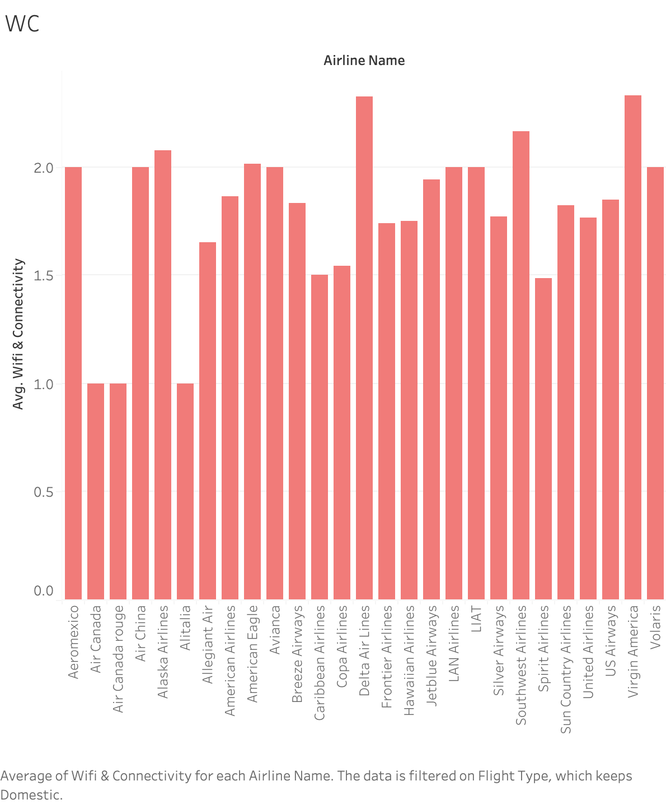

Figure 33

The above distribution shows the average **satisfaction scores** given by the customers in the Wi-fi & Connectivity department for airlines in the **domestic category**. Y-axis represents the average satisfaction scores, and the X-axis represents the airline names. From this distribution, we extracted the name of the airline with the **lowest** average satisfaction score for the Wi-fi & Connectivity department and that which satisfies the

observation count for computing statistical proof on which we based our recommendations for that airline.

The airline's name is **Spirit Airlines.**

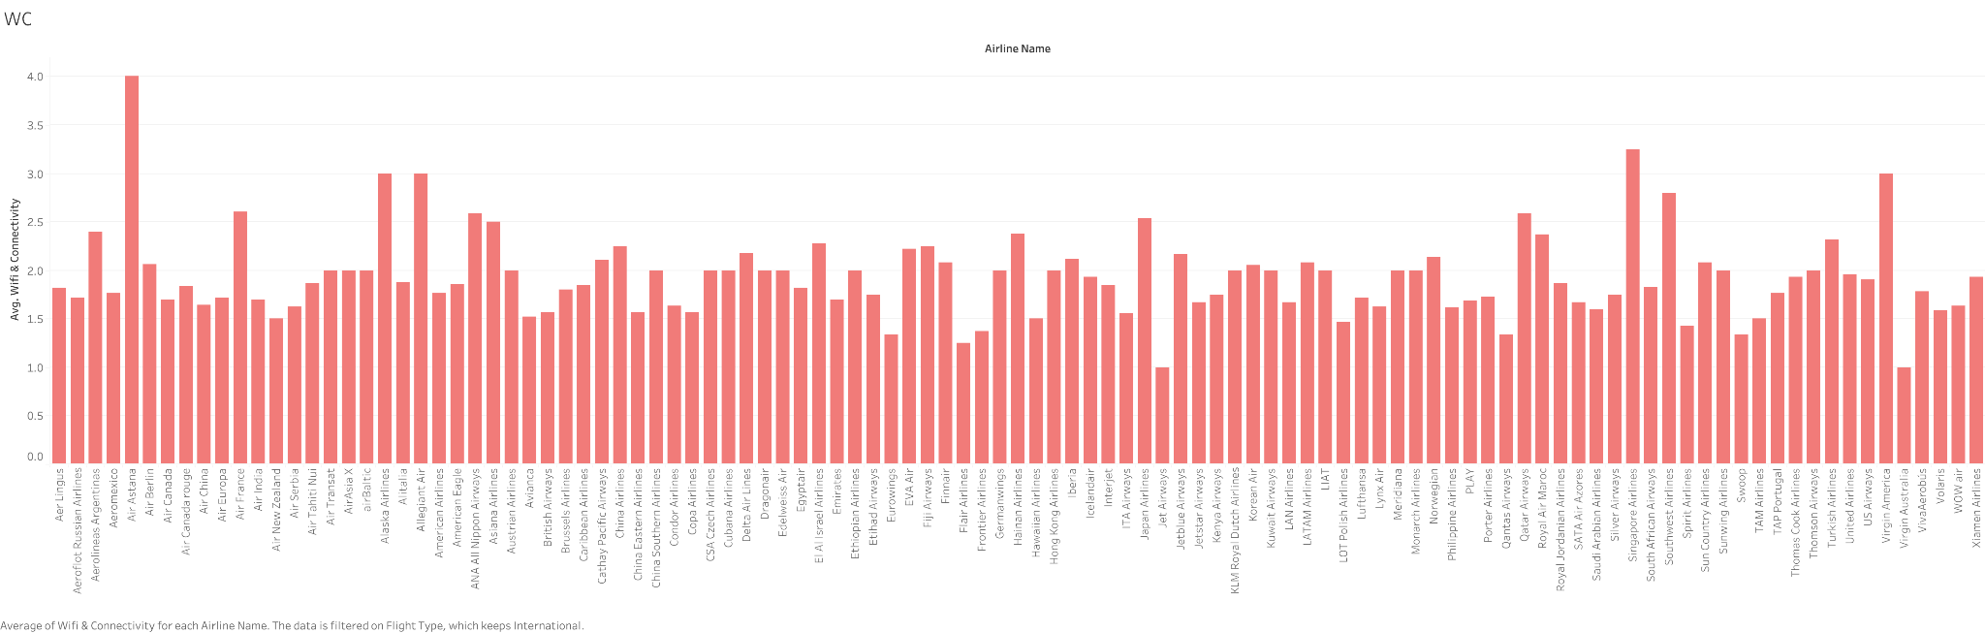

Figure 34

The above distribution shows the average **satisfaction scores** given by the customers in the Wi-Fi & Connectivity department for airlines in the **international category**. Y-axis represents the average satisfaction scores, and the X-axis represents the airline names. From this distribution, we extracted the airline's name with the **lowest** average satisfaction score for the Wi-Fi & Connectivity department and that which satisfies the observation count for computing statistical proof on which we based our recommendations for that airline.

The airline's name is **Flair Airlines.**

For both International and domestic flight types in the Wi-Fi & Connectivity department.

|  |  |  |  |  |  |  |  |
| --- | --- | --- | --- | --- | --- | --- | --- |
| **Department Name** | **Flight Type** | **Air Line Name** | **Other Airlines Observations** | **T-test** | **P-Value** | **One-Tail P- Value** | **Result** |
| Wi-fi and Connectivity | Domestic | Spirit Airlines | 1133 | -7.10662 | 7.10E-11 | 3.55E-11 | Significant |
| Wi-fi and Connectivity | International | Flair airlines | 1365 | -2.659812 | 0.07490916 | 0.0374545 | Significant |

Table 9

The two groups in comparison in these T-tests are.

**Group 1**: The average satisfaction score for the Wi-Fi & Connectivity department of the airline we want to compare in the **international/domestic** airlines population.

**Group 2:** The average satisfaction score for the Wi-Fi & Connectivity department of all the other airlines (except the ones in Group 1) in the i**nternational/domestic** airlines population.

**H0 (Null Hypothesis):** The average satisfaction score for the Wi-Fi & Connectivity department of the specific airline(s) is equal to or greater than the average satisfaction score of all other airlines.

H0: u1>=u2

**H1 (Alternative Hypothesis):** The average satisfaction score for the Wi-fi & Connectivity department of the specific airline(s) is less than the average satisfaction score of all other airlines. This hypothesis is what we are testing for.

The alternative hypothesis can be formally expressed as

H1: u1<u2

From the above table, if the result is “significant,” we reject the null hypothesis in favor of the alternate hypothesis and conclude that the average satisfaction score for the Wi-fi & Connectivity department of the airline(s) is less than the other group with which we are comparing it against.

We provide recommendations to the airline businesses based on this statistical proof.

**Recommendations for domestic:**

**Optimized Wi-Fi Packages for Solo Travelers**:

Tailor a variety of Wi-Fi packages to cater to solo travelers. These packages can include benefits such as dedicated bandwidth and priority access to streaming services, enhancing the overall in-flight experience for solo travelers.

**Strong Wi-Fi Infrastructure for Economy Class**:

Invest in robust Wi-Fi infrastructure that can support high-quality streaming for passengers using their personal devices. Establish partnerships with streaming platforms to offer a wide range of content that passengers can easily access.

**Recommendations for International**:

**Improving Wi-Fi Infrastructure for Quality Streaming Services**:

Recognizing the growing demand for entertainment options onboard, airlines can improve their Wi-Fi infrastructure to support high-quality streaming services in economy class. This enhancement aims to cater to passengers' entertainment needs on international flights, enriching their travel experience.

**Introducing Exclusive Wi-Fi Packages for Business Class**:

Introduce premium, high-speed Wi-Fi packages that are tailored specifically to meet the connectivity needs of business class travelers. These packages guarantee uninterrupted connectivity, allowing for seamless work during long-haul flights.

**Question 5:**

**How are the flights performing according to the satisfaction score given by the travelers for the Ground Service department?**

**Ground Service:**

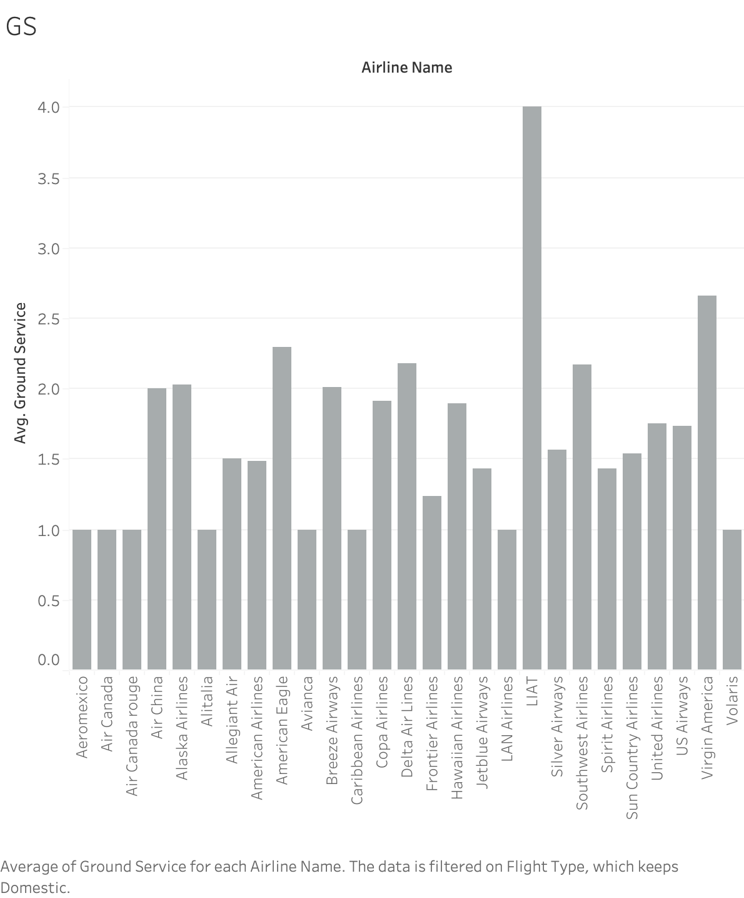

Figure 35

The above distribution shows the average **satisfaction scores** given by the customers in the Ground Services department for airlines in the **domestic category**. Y-axis represents the average satisfaction scores, and the X-axis represents the airline names. From this distribution, we extracted the name of the airline with the **lowest** average satisfaction score for the ground services department and that which satisfies the observation count for computing statistical proof on which we based our recommendations for that airline.

The airline's name is **Frontier Airlines.**

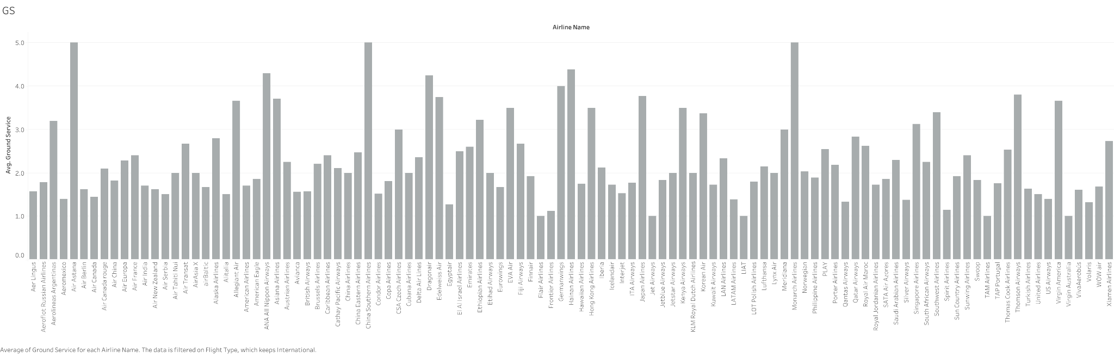

Figure 36

The above distribution shows the average **satisfaction scores** given by the customers in the Ground Services department for airlines in the **international category**. Y-axis represents the average satisfaction scores, and the X-axis represents the airline names. From this distribution, we extracted the airline's name with the **lowest** average satisfaction score for the ground services department and that which satisfies the observation count for computing statistical proof on which we based our recommendations for that airline.

The airline's name is **TAM Airlines**.

For both International and domestic flight types in the Ground Services department.

|  |  |  |  |  |  |  |  |
| --- | --- | --- | --- | --- | --- | --- | --- |
| **Department Name** | **Flight Type** | **Air Line Name** | **Other Airlines Observations** | **T-test** | **P-Value** | **One-Tail P- Value** | **Result** |
| Ground Service | Domestic | Frontier Airlines | 1146 | -7.99929 | 3.81E-13 | 1.90E-13 | Significant |
| Ground Service | International | TAM Airlines | 1354 | -2.94363 | 0.0102 | 0.005 | Significant |

Table 10

The two groups in comparison in these T-tests are.

**Group 1:** The average satisfaction score for the Ground Services department of the airline we want to compare in the **international/domestic** airlines population.

**Group 2:** The average satisfaction score for the Ground Services department of all the other airlines (except the ones in Group 1) in the **international/domestic** airlines population.

**H0 (Null Hypothesis):** The average satisfaction score for the Ground Services department of the specific airline(s) is equal to or greater than the average satisfaction score of all other airlines.

H0: u1>=u2

**H1 (Alternative Hypothesis):** The average satisfaction score for the Ground Services department of the specific airline(s) is less than the average satisfaction score of all other airlines. This hypothesis is what we are testing for.

The alternative hypothesis can be formally expressed as

H1: u1<u2

From the above table, if the result is “significant,” we reject the null hypothesis in favor of the alternate hypothesis and conclude that the average satisfaction score for the ground services department of the airline(s) is less than the other group with which we are comparing it against.

We provide recommendations to the airline businesses based on this statistical proof.

**Recommendation for domestic**:

**Family-Friendly Check-In Services**:

Introduce dedicated check-in counters specifically designed to cater to the needs of families with young children. Ensure that the staff at these counters are trained to aid and support to families. Additionally, consider offering amenities such as stroller rentals, conveniently located diaper-changing stations, and engaging play areas.

**Expedited Services for Business Travelers**:

Streamline the travel experience for business travelers by providing expedited services tailored to their specific needs. Offer dedicated check-in counters, security lanes, and boarding procedures to enhance efficiency and convenience, particularly on domestic flights. This will help business travelers save valuable time and ensure a smooth travel experience.

**Recommendations for International**:

**Enhanced Customer Service at the Airport**:

Train staff in customer service excellence, focusing on friendliness, efficiency, and problem-solving skills. Provide multilingual staff to assist international travelers. Establish clearly marked information desks for immediate assistance.

**Improved Baggage Handling**:

Invest in advanced baggage handling systems to reduce lost or delayed luggage incidents. Offer real-time baggage tracking through a mobile app. Provide expedited baggage services for premium passengers.

**Streamlined Immigration and Customs Procedures**:

Collaborate with airport authorities to expedite immigration and customs processes for passengers. Offer fast-track immigration services for frequent travelers, business class, or first-class passengers.

**CONCLUSION:**

The Airlines Reviews Sentiment Analysis offers a thorough analysis of airline industries using a large amount of data to derive significant insight into customer satisfaction across various flight-related issues. The research has made significant progress in analyzing and measuring passenger experiences through rigorous data preparation, exploratory analysis, and advanced sentiment analysis tools like VADER and TextBlob.

The project's main findings show that domestic and international travelers typically had lower satisfaction levels in areas like seat comfort, in-flight entertainment, food and beverages, cabin staff service, Wi-Fi connectivity, and ground services. Seasonal patterns in sentiment scores and the variations between domestic and international travel offer significant insights into the preferences and experiences of passengers across time.

The analysis has successfully identified airlines with lower sentiment scores and offered specific suggestions for improvement. The analysis has strengthened the robustness of its findings by utilizing statistical techniques such as Welch's T-test, which assures that the suggestions are based not only on observational data but also on statistically significant changes.

This project's capacity to convert unprocessed data into valuable insights is one of its most outstanding achievements. The following analysis-based recommendations are geared toward improving customer satisfaction and are unique to certain aspects of the flight experience. These suggestions include enhancing in-flight amenities, making the most of ground services, and customizing itineraries for different kinds of passengers.

In conclusion, this study offers evidence of the effectiveness of data analytics in the aviation sector. It has successfully illustrated how data analysis and interpretation, done right, can significantly enhance operational effectiveness and customer experience. Researchers looking to understand the dynamics of passenger happiness in the airline industry and airline firms aiming to improve their service offerings can benefit significantly from the insights gathered from this project. This project presents practical recommendations and solutions that can be applied in the real world to raise the standard of air travel and contribute to the collection of knowledge regarding airline passenger behavior.

**References:**

**Dataset**:  [SkyRatings: Unleashing 23K+ Airline Reviews! | Kaggle](https://www.kaggle.com/datasets/khushipitroda/airline-reviews)

**Matplot.pyplot**- J. D. Hunter, "Matplotlib: A 2D Graphics Environment, Computing in Science & Engineering”, <https://ieeexplore.ieee.org/document/4160265>

**Pandas**- W. McKinney, AQR Capital Management, pandas: a python

data analysis library

**NumPy**-  ​​Oliphant, T. E. (2006). NumPy: A fundamental package for scientific computing with Python. Computing in Science & Engineering, 9(3), 10-20. <https://ieeexplore.ieee.org/document/4160250>

**Seaborn**- Waskom, M. (Apr,2021). seaborn: statistical data visualization. Journal of Open-Source Software, <https://joss.theoj.org/papers/10.21105/joss.03021>

**Pickle**- Amos, D. (2021, October 1). Understanding Python Pickling and Unpickling. Real Python. <https://realpython.com/python-pickle-module/>

**Nltk**-  Bird, S., Loper, E., & Klein, E. (2009). Natural Language Processing with Python. <https://www.nltk.org/book/>

**Vader lexicon**-  Hutto, C. J., & Gilbert, E. (2014). VADER: A Parsimonious Rule-Based Model for Sentiment Analysis of Social Media Text. <https://ojs.aaai.org/index.php/ICWSM/article/view/14550/14399>

**Legend from Matplot**- <https://matplotlib.org/stable/api/_as_gen/matplotlib.pyplot.legend.html>